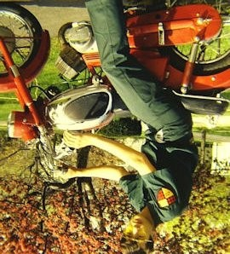
The Hot Grips® Story - Early Motorcycle Involvement:
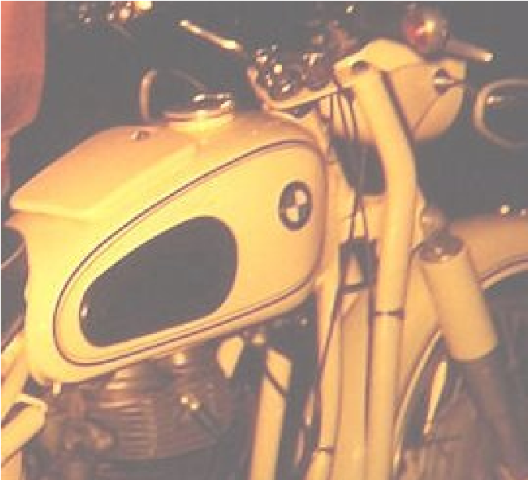
In 1967 I bought my very first used motorcycle for $200. It was a 1965 Yamaha YA-6 125cc bike that gave me my first taste of freedom from home. I couldn't possibly afford a car. My Dad couldn't participate in helping me buy a motorcycle because he was out of town, so my Mom went out with me and helped me load the motorcycle into the side of our large VW Microbus. I didn't know how to shift, so I drove around the neighborhood (which was my daily newspaper route), in 2nd gear. Silly as it sounds I just left it in one gear and kept going around and around the same "course" until finally a police car pulled me over. I was having a great time "practicing" on my new motorcycle, and I explained that I wasn't speeding since I couldn't shift out of 2nd gear, and he let me go without a ticket. He told me to go home and to give my neighbors a chance to get some sleep without that noise buzzing by their house every 5 minutes.

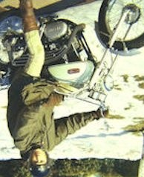
BMW R27 single vertical cylinder 250cc Motorcycle Coast to Coast: In 1967 I fell for a used white BMW model R27, which was a vertical single 250cc that wasn't seen much in the USA. I crossed the USA from Connecticut to California in 7 days on it. By the time I reached San Diego, the generator was acting up, and I was tired of riding the interstate highways. So, I crated it up and shipped it back to Connecticut by truck, flying myself home. I sold it for $600. and it looked as pretty as the day I first bought it, but it had to go. I used to take my 125 YA6 street bike to the woods and ride around this dirt track I had found, jumping it whenever I had the chance. In 1969 I wanted to move up to a new 350cc Yamaha twin, but the dealer was not willing to give me a good price and they were $795. But he would give me a good price on the white Enduro bike - the Yamaha 125cc AT-1.

I traded in the 125 Yamaha YA6 street bike with some cash for the AT-1 and was thrilled at the ability to go thru mud and over logs with those "universal tread" tires (not quite knobby tires). They were much better than street tires in the mud, but not aggressive like a knobby tire. In my very first Enduro I rode the AT-1 Enduro bike with the universal tread tires and wore my school boots that had no toe-protection, they were just pull-on walking boots. Mid-way in the 65 mile event, I dropped the bike in a very wide river crossing where water was up to the middle of the engine. I dragged it out to the river bank edge which was a long struggle and had to figure out how to get the water out of the engine and exhaust pipe. I removed the spark plug, put it upside down on the handlebars and ran the kick starter until no more water drained out. It took about an hour to get it running. My first race: DNF.
I had read in a magazine about this really serious enduro bike called a Penton SixDay 125, which had an air intake way up under the gas tank on the frame, and it came with full knobby tires. I had to have a better enduro bike than my Yamaha AT-1, so I dug into my paper route savings. The 1970 Penton was a harsh bumpy ride on the road, but in the woods, it was like magic. It cost $625. and I bought some real enduro "Full-Bore" boots with steel toes for $50. Also a waxed British Barbour riding suit, and I was really enduro ready.
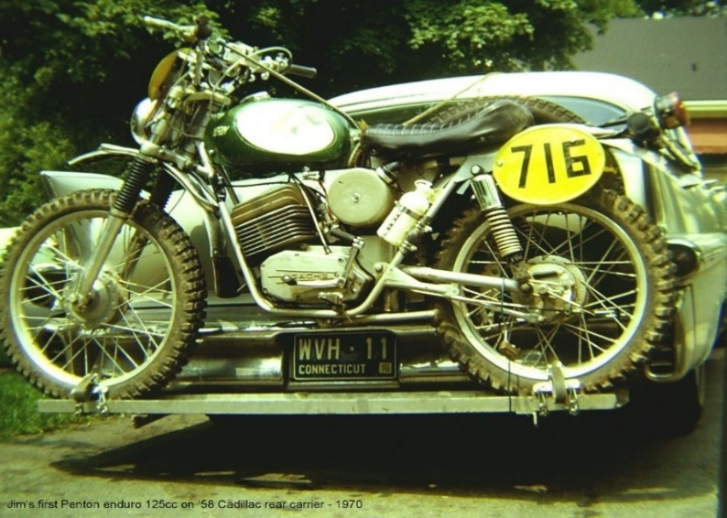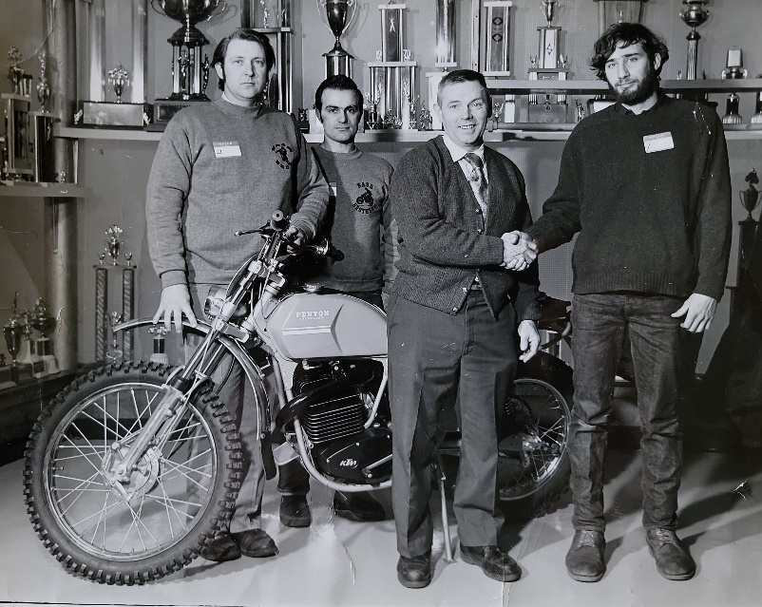
Nash Brothers Motorcycles in New Haven, CT sent me to Penton Imports as a mechanic to learn engine rebuilding.
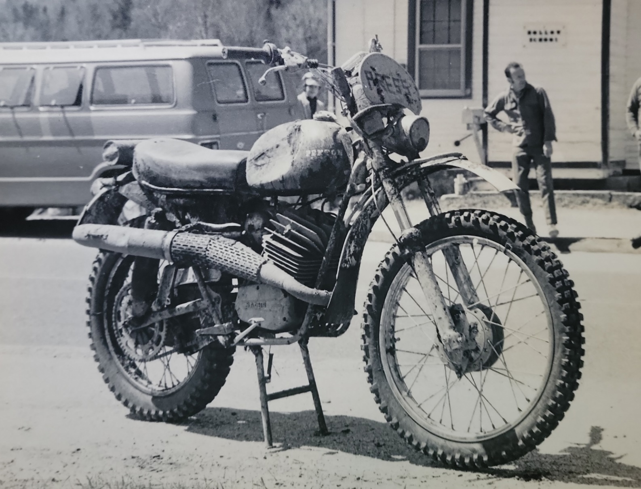
The steel tank Penton was called the ‘125 Six-Day‘. I knew what that was referring to because I had read articles about the International Six Day Trial in the motorcycle magazines. I had read about the whole Penton clan in Europe at the Six-Days, and that was something I would love to do, though I didn't know much about it. Putting your bike in a Parc Ferme overnight and having very limited amounts of time to fix things, having gas stops, checkpoints, support vehicles, and competing 6 days in a row...in Europe. I was just fascinated by this kind of riding and really took to enduros quickly, winning lots of trophies in short order. I remember the steering geometry of the Penton allowed it to straighten itself out no matter how much the rear wheel kicked out to the side. And I had more than a few ‘tank-slappers’ with it, but it always recovered on it's own. The bike was just incredible, so serious at its mission. I rode all of the enduros I could, brought the Penton to college and took it apart outside to bring it into my dorm room. I always went over the parts looking for breakage, but the bike was very well made so I had few problems with it. I shared this room with another student and he didn't mind, he thought it was neat. Most of my junior and senior year weekends at college were spent going to New England and Canadian enduro events. When the 1972 college graduation ceremony conflicted with the 3-day “Berkshire” enduro, there was no way I was going to miss that 3 day event for a crummy college graduation. The college mailed my diploma later in the summer. So I had a 4 year BA degree in Psychology which I had no plans to use.
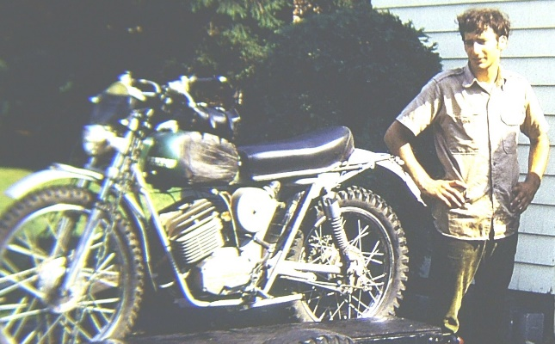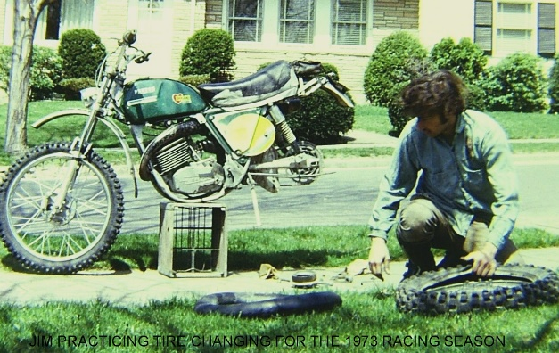
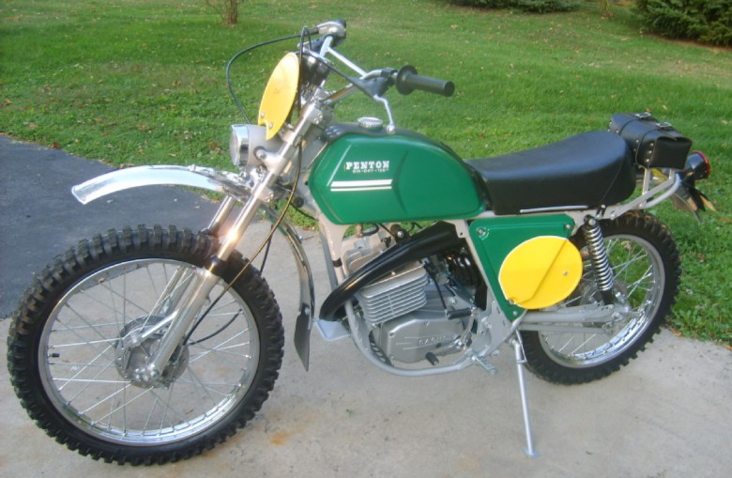Meeting John Penton of Penton Imports / Hi-Point Racing Accessories: This (graduation substitute) turned out to be a very good weekend for me, although the engine seized on a road section. At that event on the 3rd day I was sitting on the side of a road with my bike all spread out on the shoulder of the road in pieces. I was nearly within sight of a time checkpoint a mile away that led back into the woods. I had used my leather-pack of tools to disassemble the exhaust pipe, carburetor, cylinder head, cylinder, etc. My only chance was to get that piston cleaned up and put it back together. I didn't know enough about 2-stroke engines at the time to understand that it was not going to happen. The aluminum piston was scored into the cylinder bore and the rings were broken and jammed into the ring lands - it was hopeless.
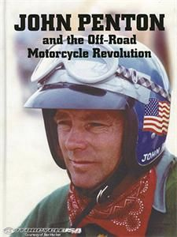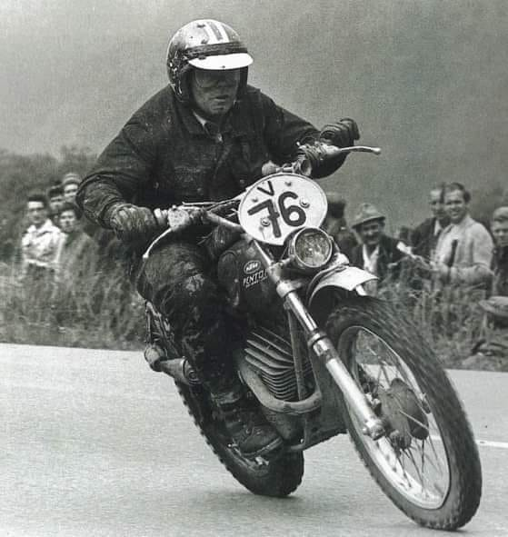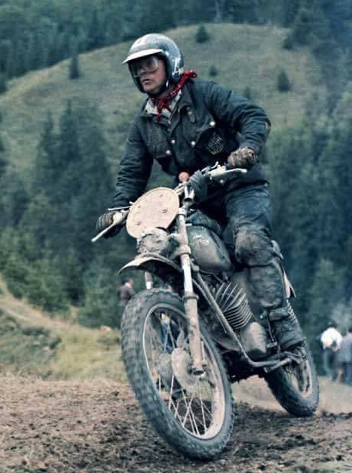

Who should stop by to offer help but John Penton in a blue Ford Maverick. He said he didn't think he had any piston and rings in his trunk, but if he could get what I needed he'd bring them back to me. He never made it back, so after I was over my late maximum of 1 hour I put the bike together and got a ride back to the campground. By then, I was miserable because I had a broken motorcycle, it was raining, and I was very cold. I changed out of my wet riding gear, and I was putting my stuff together to drive home when John's son Jack Penton (one of the dozen or so stars of the US Enduro and ISDT world) visited me. He asked if I could come over to their camp as his dad wanted to speak to me. John Penton asked me what I was doing with my life and invited me to drive to Ohio with my broken motorcycle, where I could get it fixed properly and perhaps work there at Penton Imports. Apparently, he was impressed by my tenacity at disassembling my bike during the event. When I brought my bike out to Ohio in my 1964 2-stroke Saab station wagon, I was quite a sight. I pulled the broken bike behind the rear bumper on the rear tire with the chain removed. The front wheel was tied into the rear facing child-seats and the rear hatch door was tied to the bike. I got a job sanding down ex-race bike frames at $2.75/ hour and was working on my bike in the after-work hours. I lived at no cost in John Penton's small duplex that he owned at the rear of his home property in Amherst, Ohio. I remember I shared the place for a time with Billy Uhl, another of the enduro and ISDT stars of that time period. My clothes were literally in boxes stacked against the wall of a closet-sized room. This was the early time of the 2nd generation Pentons, called the CMF Pentons (CMF stood for Chrome Moly Frames). The early CMF bikes did not have the amazingly effective frame-backbone air intakes that the first generation with the rounded steel tanks had. There were a few trips to ISDT Qualifiers in the Penton Cycleliner (pictured below), which was a converted old US Mail bus. It was outfitted with many sleeping bunks and would be driven non-stop, with driver changes while on the interstate (still moving along at 55 mph). I got a chance to drive it, and it sure was good at hauling a lot of motorcycles and riders to the events. They carried spare parts in the bus and had a chemical toilet in a closet.

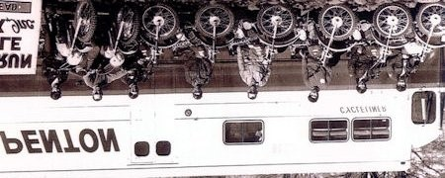

Cycleliner: Jack Penton, Tom Clark, Dane Leimbach, Paul Danik, Doug Wilford, Jim Hollander, Jeff Penton, Billy Uhl.

While I was Penton Imports in Ohio, I persuaded an engineer into building a prototype CMF bike with a "frame breather" backbone like the earlier steel-tank Penton. I remember taking it one very rainy day to a river and testing it to see how deep it could stay running. I didn't last very long sanding motorcycle frames and doing that kind of work, and soon got into a personality conflict with John's brother Ted, who invited me to go home. He did it without talking to his brother John, who got annoyed about it happening without his knowledge, and John called me at home in Connecticut afterwards and apologized.

1972 Czechoslovakia ISDT -Border Crossing - Machine Guns and Barbed Wire Fences: I continued to race the Penton 125cc that summer doing well but not riding the Qualifiers for the US Team. John Penton felt I should ride in the Six-Days, and arranged for me to go to Czechoslovakia to the ISDT that September of '72, riding as a Canadian on a factory prepared 125cc Penton. I joined the Penton ISDT Tour, a chartered flight which most of the competitors and their families used to go to the ISDT. It included a long boat ride on the Danube River, we visited a castle, and had a good time seeing the sites. I ended up at the KTM factory where they made the Penton motorcycles, although at that time most of their production was building pedal-bicycles. They had not yet changed the Penton motorcycles into KTMs, although they did have some years of building KTM motorcycles and mopeds for the European market. Visiting the Research and Development Department at the KTM factory was a real treat for me. By the way, KTM stands for Kronreif, Trunkenpolz, and Mattighofen. Engineer Hans Trunkenpolz started the business as a metalworking shop in 1934, produced their first motorcycle in 1951, and Mattighofen is the small town in Austria where the factory is located. Ernst Kronreif was a businessman who became a large stockholder of the business in 1955. The first Penton motorcycle was brought to the USA in 1968, through John Penton’s efforts.
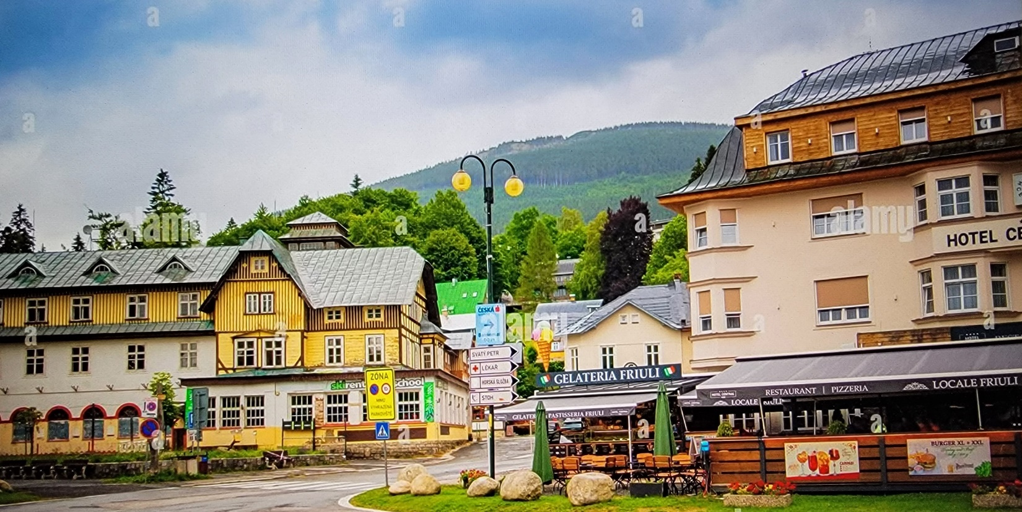
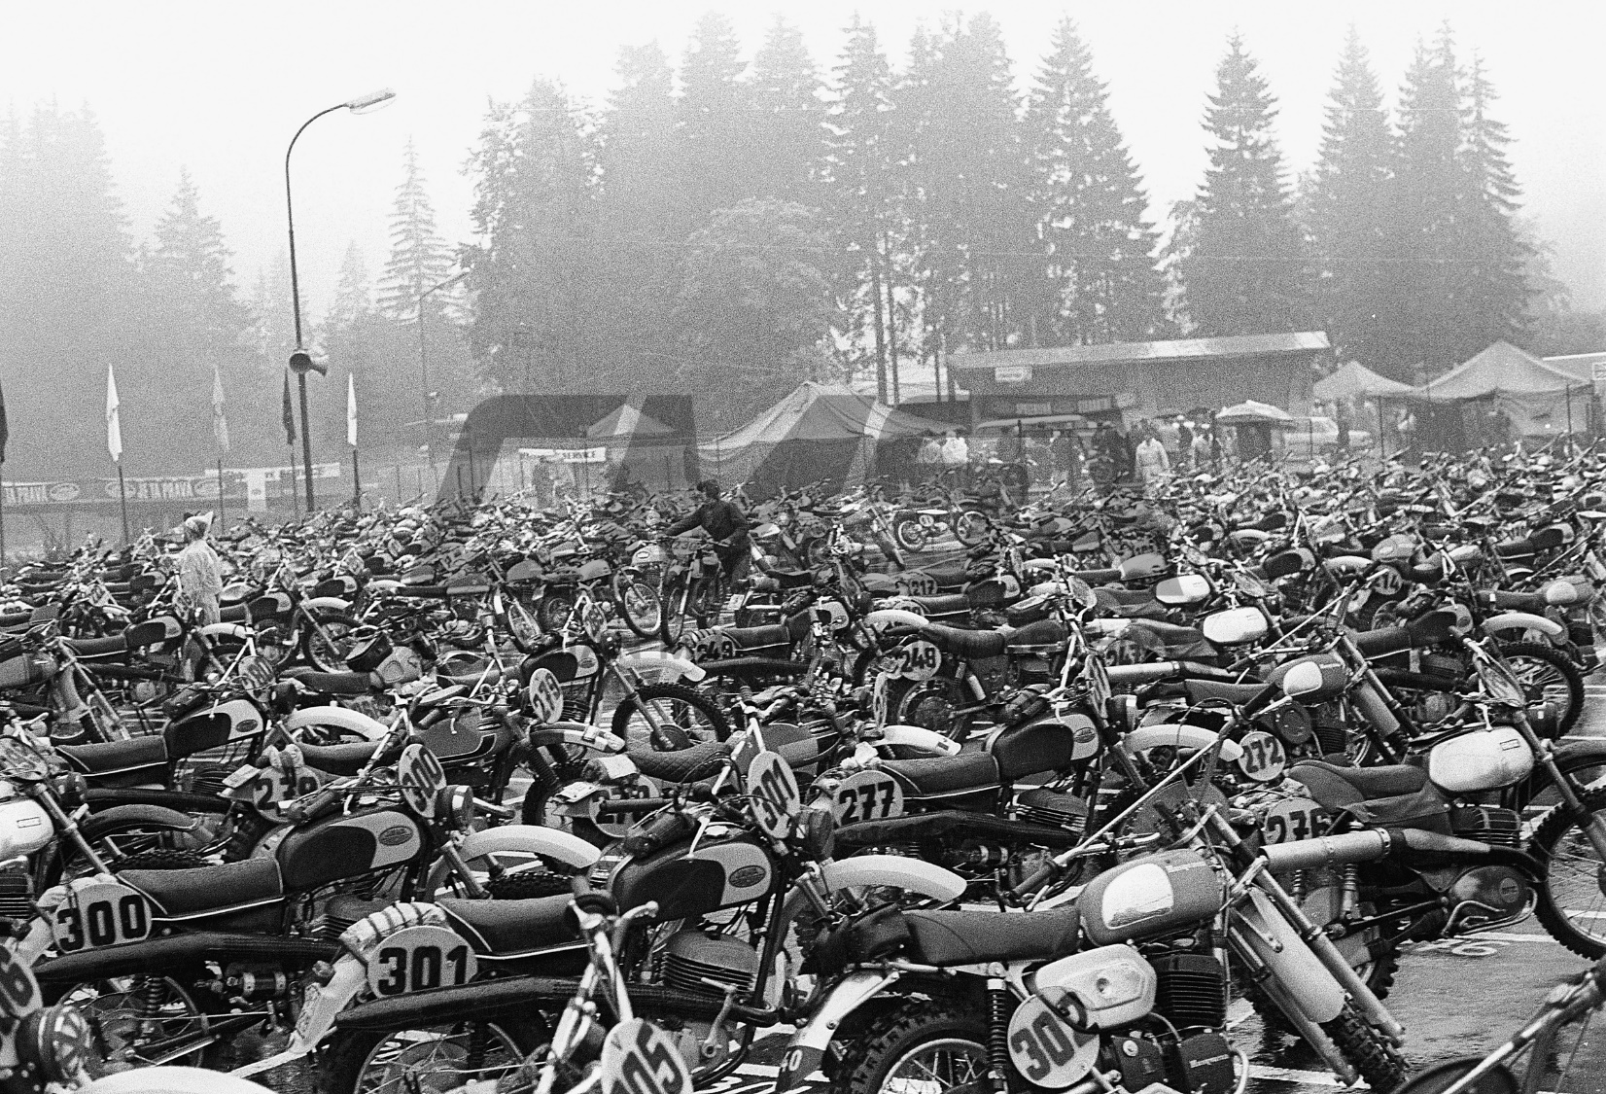
After the KTM factory we were off to the Six-Days. The ISDT was held in a colorful resort town called Spindleruv Myln. I remember when the Penton Tour bus reached the border crossing to Czechoslovakia, there were guards with machine guns, tall wooden towers, guard dogs, and lots of barbed wire. They had two rows of barbed wire with a No-Man’s Land in between. It was like a scene out of The Great Escape movie. One of the US team riders was following the bus thru the border crossing and pulled a big wheelie. It was a very tense moment but we all continued on unmolested into the drab countryside. Czechoslovakia generally was very dull, lots of poverty and simple living. It was a Communist controlled country. There were many small Skoda cars, and big black government cars that looked like they came from the early 1960s.
In the hotel, 8 U.S. riders were stuffed into one room, and there was one bathtub down the hall. Since it rained quite a lot during the event, there was a real mess in the room with everyone trying to dry their riding gear and boots each night. The humidity level in the room was awful. At one point I needed to get my street clothes cleaned, I had run out of dry clothes and someone told me that the hotel staff was doing washes for people. I assumed they were doing it for free, the way it was told to me. So I gave them my clothes and when I picked them up at the front desk, I was quite upset when they wanted $5. ($36. In 2023 dollars) so there was a bit of a scene at the front desk. I very grudgingly paid them $5. and commented at how excessive that was. The response from the hotel maid was: "Zie haben das gelt" which with my high school German, translated into "You have the money". They viewed all of us Americans as wealthy. They had a water shortage problem at the hotel, so many of us had to re-use the same muddy luke-warm water in the tub. At the Six-Days Metzler and Barum knobby tires were available to us for $8. each. Quite a few came back on the plane when we returned to the US. As that was a small fraction of the USA cost.

Mud covered back, Jim was Rider 105 in Czechoslovakia riding with a Canada green helmet with a white center stripe.
I honored John Penton's faith in me by staying on a gold medal pace until the final 3 hours of the 6th day, when my stock (non-Teflon lined) throttle cable got too much dirty water into it and I lost many minutes changing it at a checkpoint.

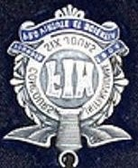
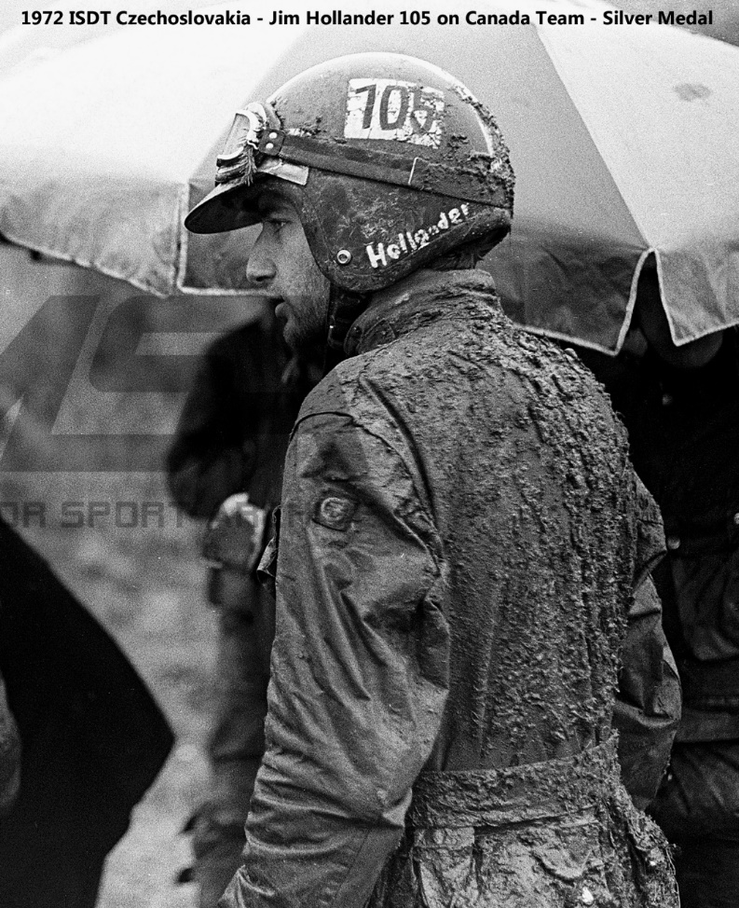

In the ISDT were supposed to change your tires in 4 or 5 minutes, but at home it would take me 30-45 minutes. So I rode the whole six days on one set of knobby tires because I didn't have the skill to change a tire quickly. Contrast this to two years later at the 1974 ISDT in Italy on a 340cc Rokon, where I had to change nine tires due to flats and chewed up knobs. Three had to be done on the side of the trail. The rocks in Italy tore up tires. The Rokon factory sent Dave Mungenast (riding as a “Canadian”) and myself on the USA team to Italy, where I picked up another silver ISDT medal. I also wrenched my knee so badly that at the following checkpoint the one of the factory KTM mechanics handed me some white powder in a folded piece of paper and told me that would help with the pain. The pain went away, and I was in another world for a few hours. When you ride that many days in a row in muddy mountainous terrain, your body goes on auto-pilot and I had no trouble staying on pace and in control.
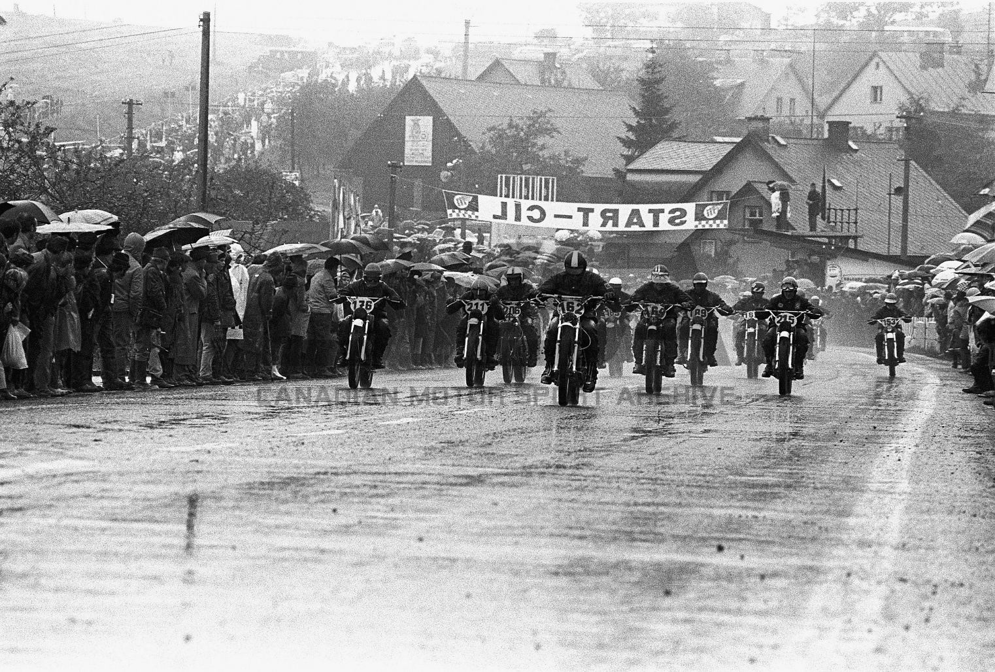

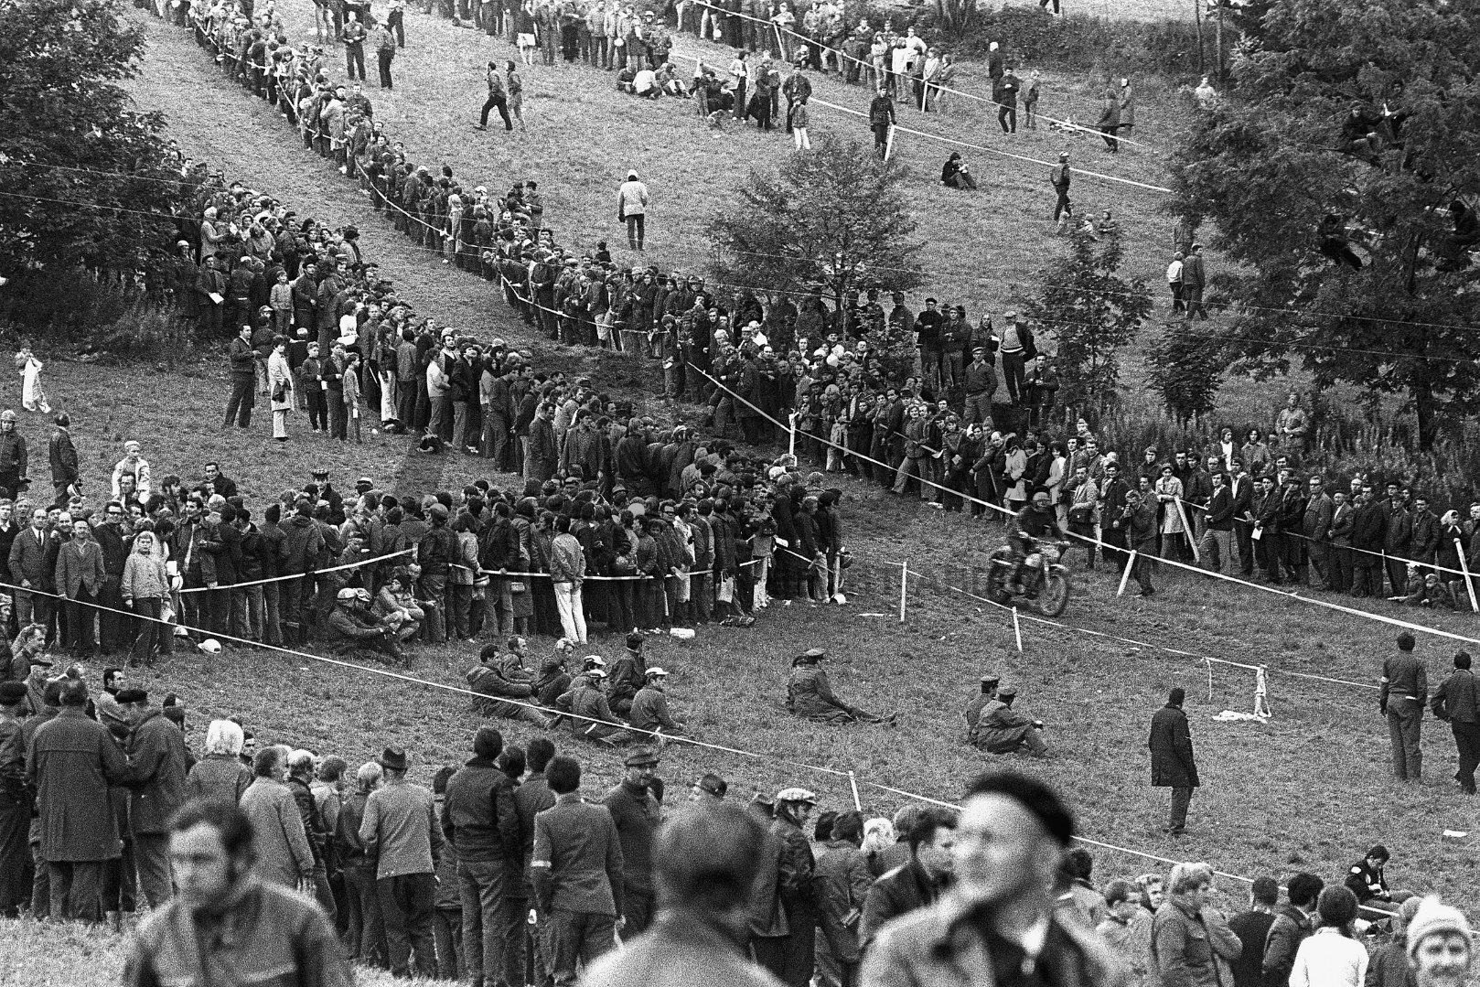
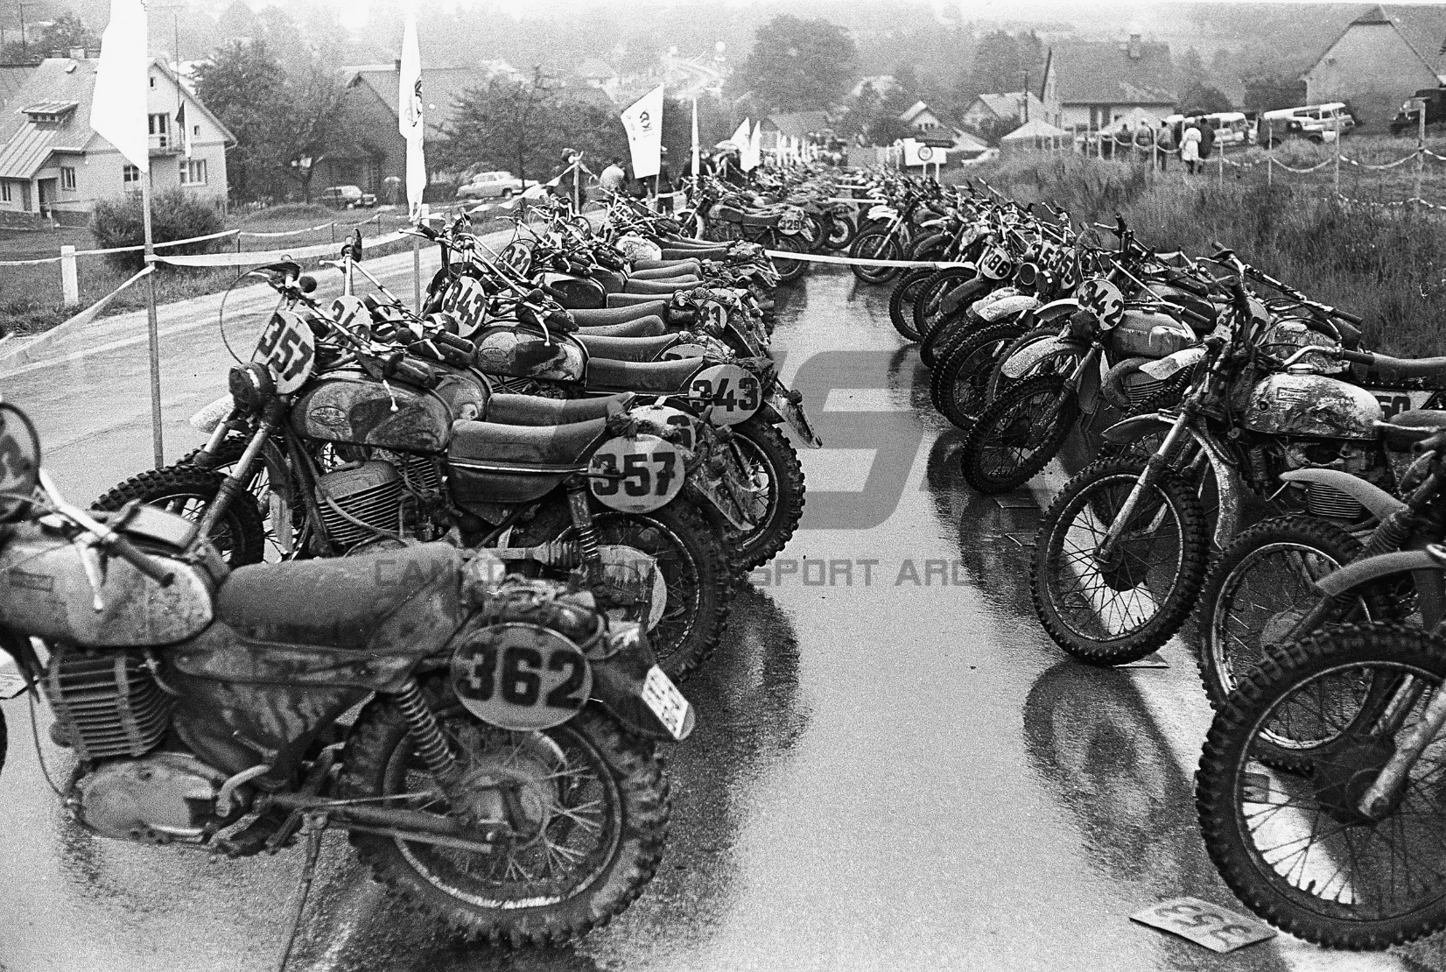

The sixth day was cold, rainy and very foggy on the trails, so much so you couldn't really see the ground very far ahead of you, so you felt your way somewhat blindly. My motorcycle throttle action started to get very difficult to move. I remember when we picked up our Pentons at the KTM factory, special Teflon lined cables were given to the 6 Penton Trophy Team riders. I was a lowly Canadian so I couldn't get one. A $5 throttle cable ended up causing me 2 minutes late into a checkpoint on Day 6, while still on gold . USA enduro organizer Al Eames was there at the Day 6 checkpoint. I remember in the rain, Al telling me he couldn't provide any assistance to me or I'd be disqualified. I already had lost any chance for a Gold Medal when I came in after my "grace time", my fingers were numb and wouldn't do what I wanted them to do. Al Eames was responsible for the ISDT in 1973 coming to the USA, held in Dalton, MA. My hands were so clumsy that I was having trouble engaging the lower throttle cable end into the carb throttle slide. Fortunately, a KTM factory man was there and he told me I didn't need to install the flat washer plate over the cable end, the one I had lost in the mud while struggling with it. I ended up spending 12 minutes changing that miserable throttle cable and got a Silver Medal in my first Six-Days event. That was as a “Canadian” in 1972, but the following four years I rode as a USA team rider, a Penton 125 in 1973, then the Rokon 340 in 1974, 1975, and 1976.

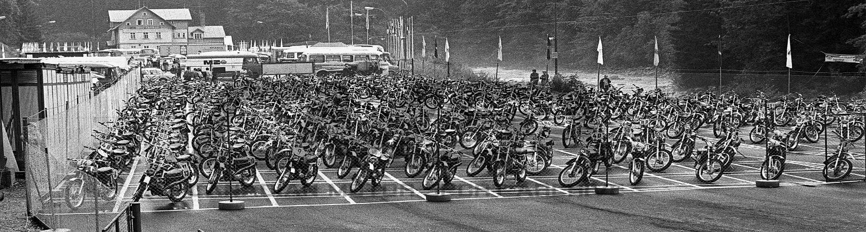

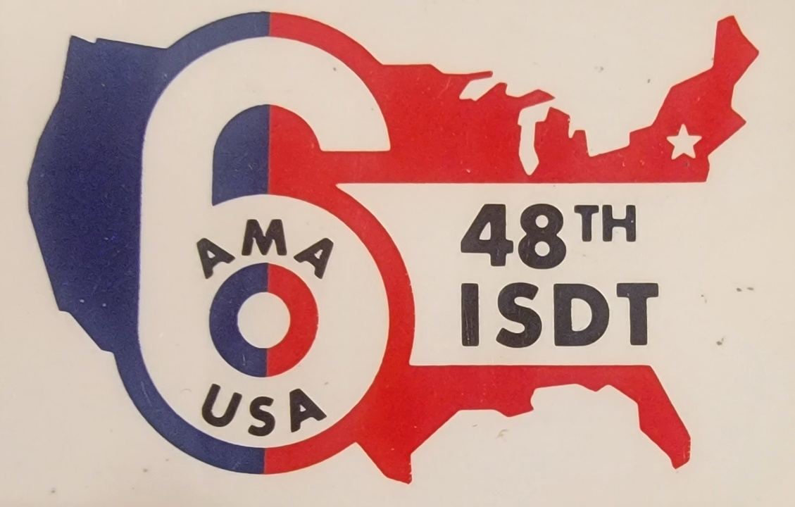

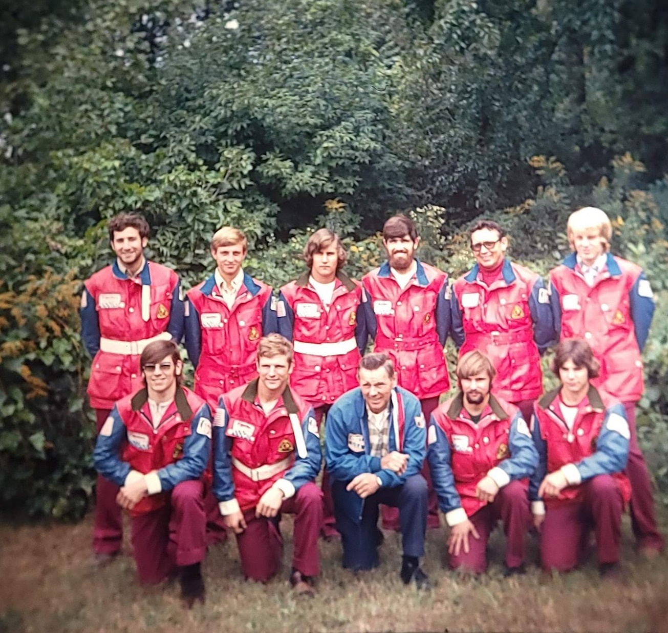

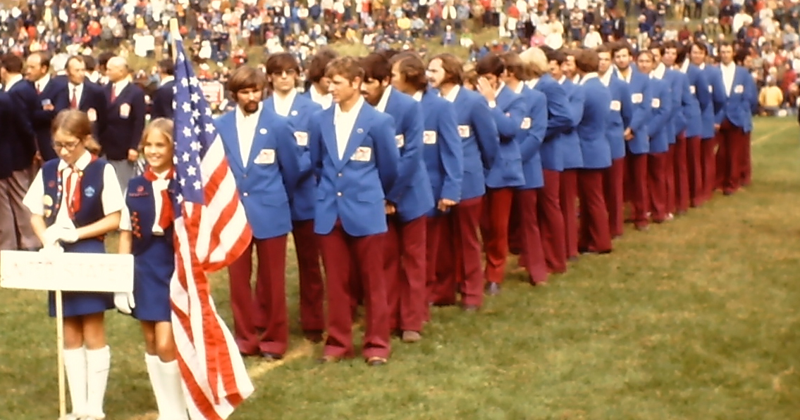

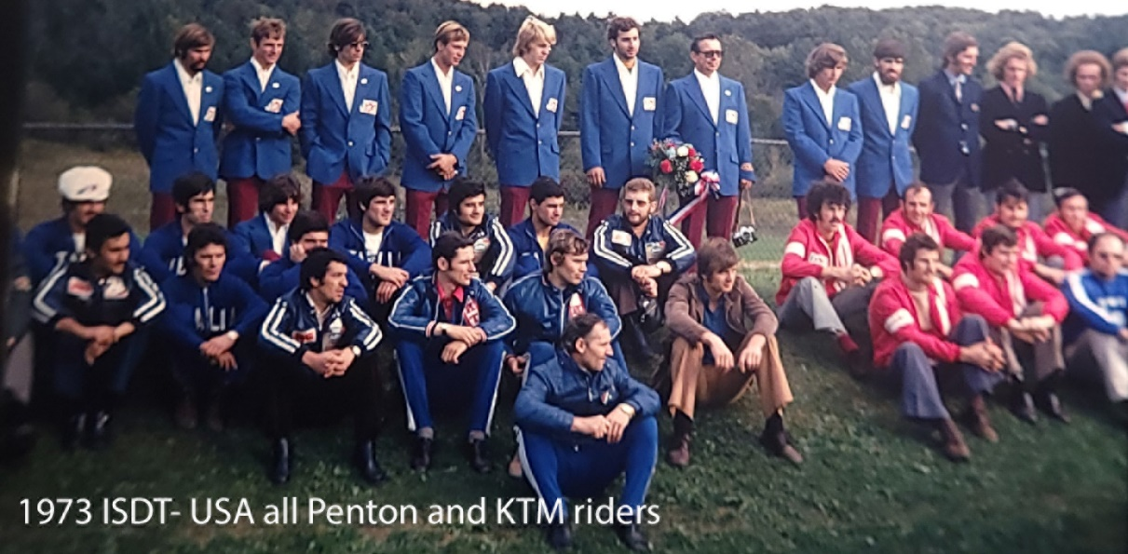

The United States Team selected for the 1973 International Six day Trial is below:

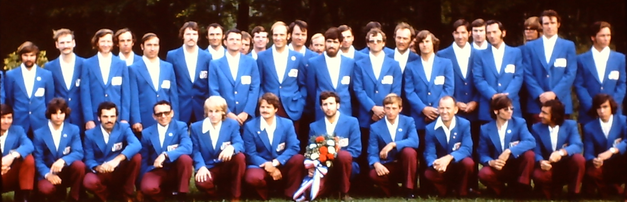

The Parc Ferme is where the motorcycles are locked up each night, riders cannot work on their bikes in this impound.

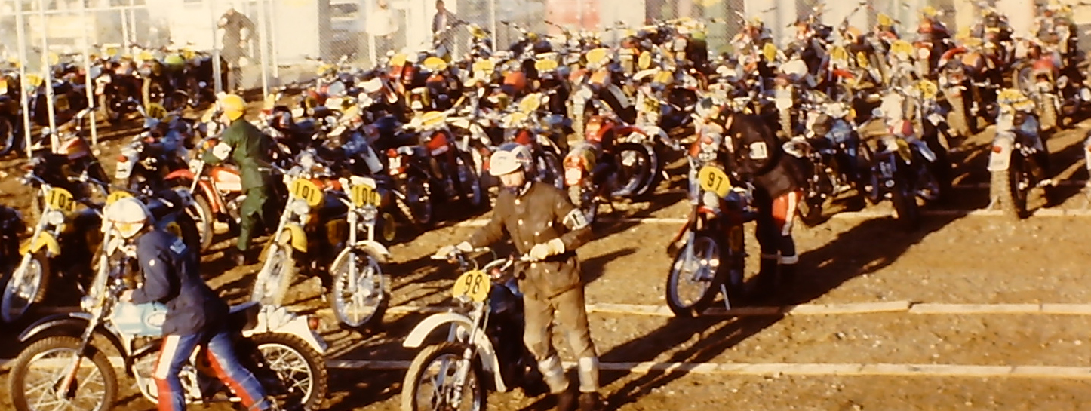

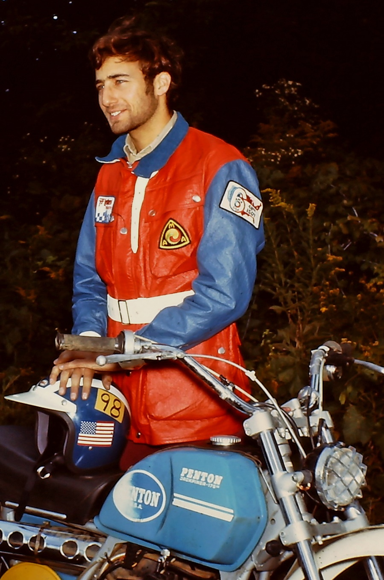

Six-Days held for the first time in the USA: In 1973 the ISDT came to the USA for the first time ever, and held in Massachusetts.

There was a series of 6 ISDT Qualifiers to try for a position on the US team. I had a great year on the Penton 125 and got 5

gold medals in a row in the Qualifiers and was going to be put on the US Team, as a "Vase B" rider. The Qualifiers categorized

the riders into "factory or sponsored riders" and "private riders". I was a "private rider" and ended up as the top scoring privateer –

number 1 on the list for the qualifying series. I had gotten very fast and was looking forward to representing the USA in my first

ISDT as a US Team rider. On the first day I was really moving fast, and surprised myself when I learned I had tied with Tom

Penton for fastest American in one of the special tests. On Day Two it rained heavily, and I lowered my tire pressure a few pounds

for better traction in the mud. I was really surprised at how well the Penton handled in the mud and rocks, and I was just flying in

this one section. I was somewhat familiar with this often-used enduro trail near the Vermont line, from previous New England

events. It was an extremely difficult very long rocky section and it seemed I could just do no wrong. As I came within several miles

of the next checkpoint (I later learned I was fairly close to it), all of a sudden, I found myself pulled off the bike like a puppet doing

several 360 degree flips in the air. I was 100% powerless to influence what was happening to me, it was that quick and unexpected.

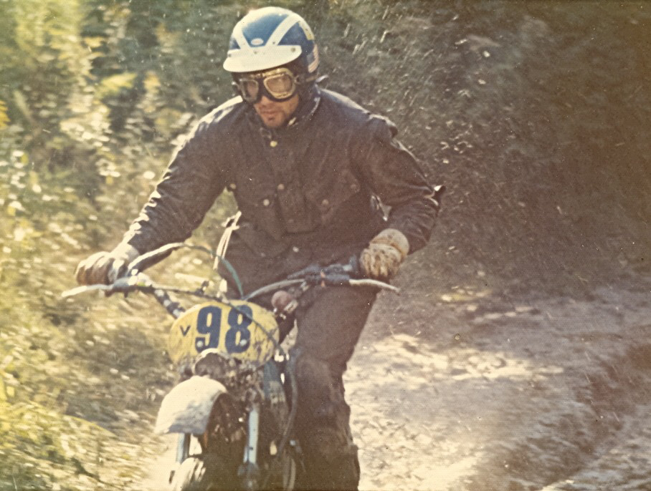

A large rock had just been dislodged from the bank of a fast trail, and in the rain I didn't see it. Apparently, the previous rider was going slow enough to spot it, but it had just been dislodged when I reached it. Many years later, one of the '73 ISDT event's workers had too much to drink after an enduro. “Tom” had something that had been bothering his conscience all these years, and just had to get it off his chest. He apologized for the part he played in that rock appearing on the trail. Tom explained that he was a course Marshall, riding the trails mixed in with the competitors. He told me he had spotted that big rock, and lazily decided it was not going to move out of position, so just left it there. He felt so bad about his role in my crash, causing the only American non-finisher on a Penton cycle that he had to get it off his conscience.
I was knocked out cold, and my motorcycle had no obvious damage though mud was hard-packed between the front number plate and the handlebars. Some spectators helped me to my feet, and I was really disoriented. Several spectators brought my bike to me, and then bump-started me down the trail. The checkpoint was not very far, and I rode to the US support van in a daze. I asked if I was late, and someone said I was 12 minutes early. I guess I was going at an unreasonable rate of speed in that section, but it felt so good, so right because of the great tire grip the lowered pressures gave, except that now that I'm at the checkpoint I didn't feel so good. I had a concussion and by the time I was due to go to the timecard clock, I felt very woozy. I remember standing next to the bike, thinking about throwing my leg over it to kick start it. My eyesight started to go black and I fell forward onto the seat. I was brought to the local hospital, and I remember lying in that ambulance and squeezing someone's hand. I was very messed up and thought I was going to die from the severe concussion. At the hospital emergency room I remember them taking off my muddy riding gear and checking me over. I couldn't speak to the ER staff, I was in shock, and they X-rayed me for broken bones and stitched up my face, put me in a room for overnight observation. They didn't do a very good job cleaning me up, I was pretty dirty and the bed sheets showed it. My father was at this event to watch, the only one he ever went to in my 9 years of racing. When he came to my bedside, his face looked strange. I had crashed many times in my few years of enduros, but never hard enough to be carried to a hospital. I had always thought I could ride at a "crash-able speed", one which might be a bad wreck, but I could still ride on. But I nearly always managed to ride on to the finish of an event, regardless of injury or bike damage. This was an exception, and it was a humbling experience. I wasn't the indestructible 22 year old that I imagined after all.
Letting the US team down with a DNF (Did Not Finish): At the hospital, in the morning when I struggled to get dressed, I looked in the mirror. I understood why my father had a tortured look on his face. My face looked like I had gone ten rounds in a boxing ring, without ever hitting back. It didn't look like me at all, with various swellings, sutures and bandages that must have frightened my father. At the end of that ISDT, I really felt like I let the USA Team down, but as it turned out, none of the 4 members of my "Vase B" team finished either for various reasons. And unfortunate Jeff Penton, part of the US Trophy Team, who was my roommate at the motel, seemed like he was even more depressed than me. Jeff had made the mistake of smearing silicone seal all around the inside of his air box, must have been on both sides of the foam air-filter. On one of the days, his bike started running really badly, and he dropped a lot of time figuring out that pieces of silicone had broken loose and clogged up his carburetor . The USA had high hopes of doing better than ever before at this first ever USA Six-Days. So the Trophy Team didn't do very well in the standings. The 4-man US "Vase A" team, all riding Sweden’s Husqvarnas, ended up 1st in the Vase-B category, which was the highest the US had ever done in Vase competition.
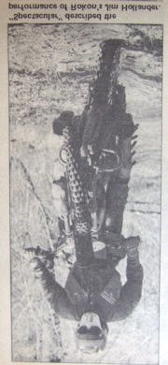
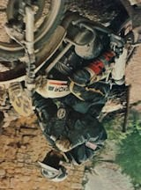
I heard later that Jeff Penton felt so bad about his causing the team problems, that he stopped riding enduros, ISDT Qualifiers and Six-Day events for many years. He just was not seen at the events anymore. He started working in Ohio at a Honda shop as a mechanic I recall, and I visited him there once. He stated he simply didn't have any interest in racing anymore, just didn't care about it. I don't know how many years he stopped riding, the next time I saw Jeff on a motorcycle was at the 30th year ISDT reunion held in Massachusetts in 2003. That was a really nice reunion, with more than 60 American ISDT riders attending. Below is a 1973 opening ceremony showing the entire USA Six-Days Team:

Switching from a Penton 125 to a Rokon 340 Enduro motorcycle: In the fall of 1973 I switched to the innovative New Hampshire built 340cc Rokon motorcycle. It had disc brakes front and rear, a torque converter automatic transmission from a snowmobile, a parallelogram floating rear brake which made the suspension work great, it was heavy and built really solid. You could crash a Rokon much harder than any other enduro bike and keep riding it in a race. They had a clever arrangement for the rear brake pedal where the pivot point was located 6 inches forward and pivoted down to the rear, and the pedal couldn't be damaged or get brush caught on it. I worked at the NH factory, raced in New England, rode for Rokon 3 years at the ISDT in Italy, Great Britain, and Austria. When I was at the Rokon factory, I liked to spend time working on my bike in R&D. They had a metal lathe that I used to lighten parts. I became a racer-advisor to a certain extent, working on ideas with their engineer Mark Hamilton and his assistant Ronnie Rouleau. I talked Mark into making a prototype "frame-breather" Rokon for me to campaign in Enduros and the ISDT Qualifiers. He modified their round backbone tube with a series of holes, and tied in the air-box without leakage into the end of that backbone 3" round tube under the seat. I also got them to make a prototype for me with a low exhaust pipe, that went under the engine, then came out to the side and up. We lowered the engine and gear-reduction box to lower the center of gravity, and did all the lightening of parts we could.

From online: Riding on a USA built Rokon 340cc Automatic. Rocky terrain was brutal on the riders with many flat tires and rear knobbies that would wear down in one day. Jim Hollander was the only American to qualify for the USA Team on a Rokon. He had to change a total of 9 tires in the event, 3 at the side of the trail, costing him his Gold at the following time checkpoint by one minute past his late grace period. The other Rokon rider was Dave Mungenast of St. Louis, MO riding on the “Canadian” Trophy Team. An unusual Six Days held in steep and dangerous mountain terrain around Camerino, Italy… there was no rain the entire event.

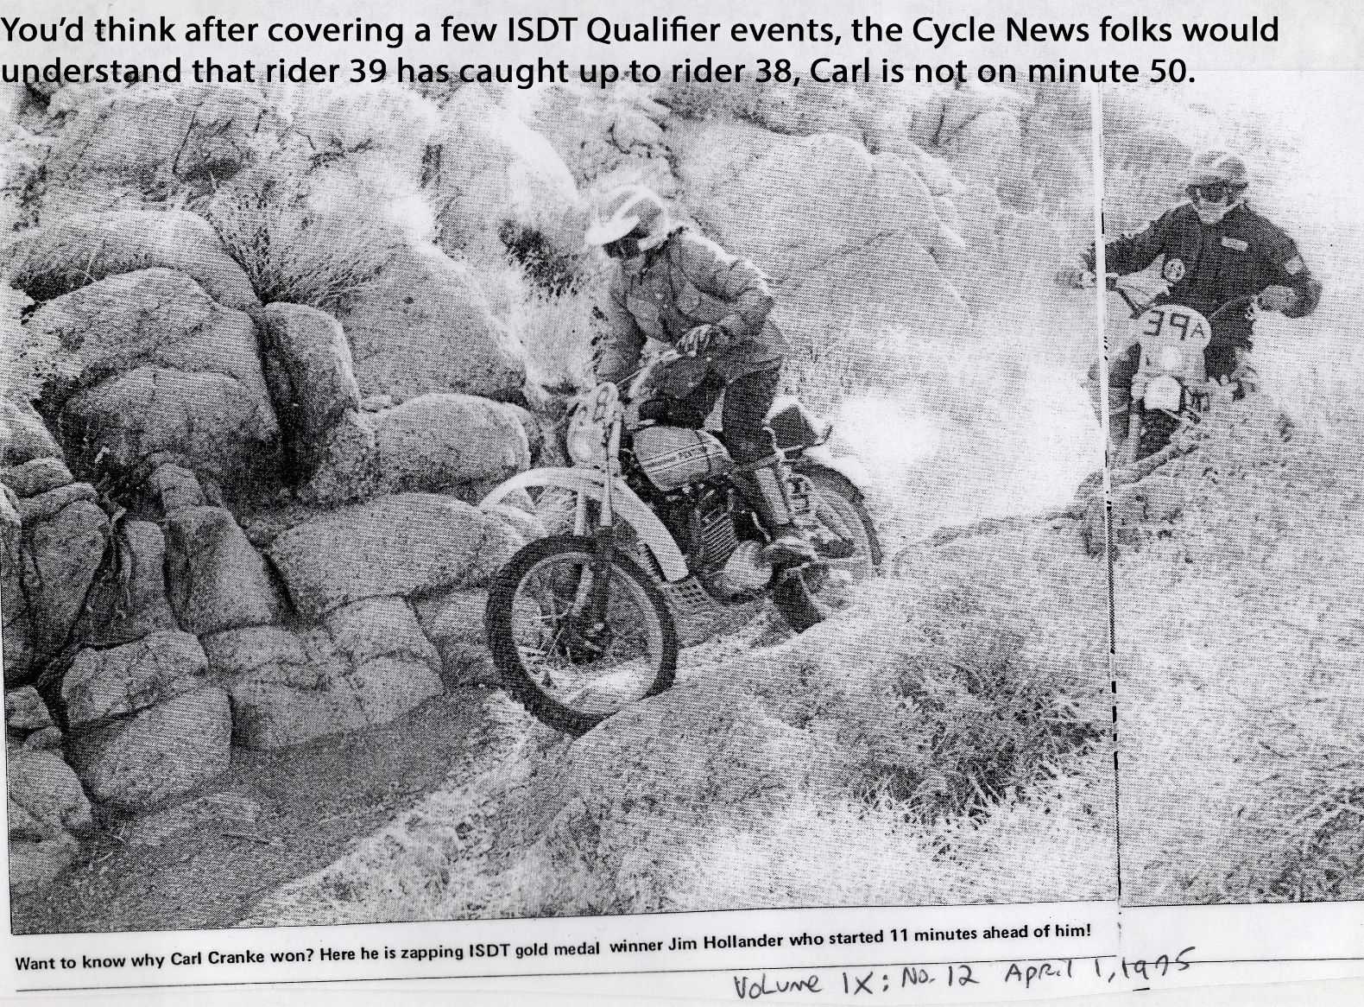

I used the Rokon in New England enduros with great success, and they made 5 of them to send to the ISDT in Great Britain (Isle of Man) in 1975. In that 6-days, all of the Rokons suffered from power loss in the middle of the event, and 3 of 5 retired. They then discovered the muffler spark arrester screen was closing with carbon build-up so the remaining bikes got their spark arrestors knocked out with a long steel punch. The event organizers had insisted that all bikes have screen spark arresters. The next year they went into production with it, and it was very fast and very competitive. They called the new model RT-1 and then they came out with the RT-2 and finally the GMR (Gold Medal Replica) model.

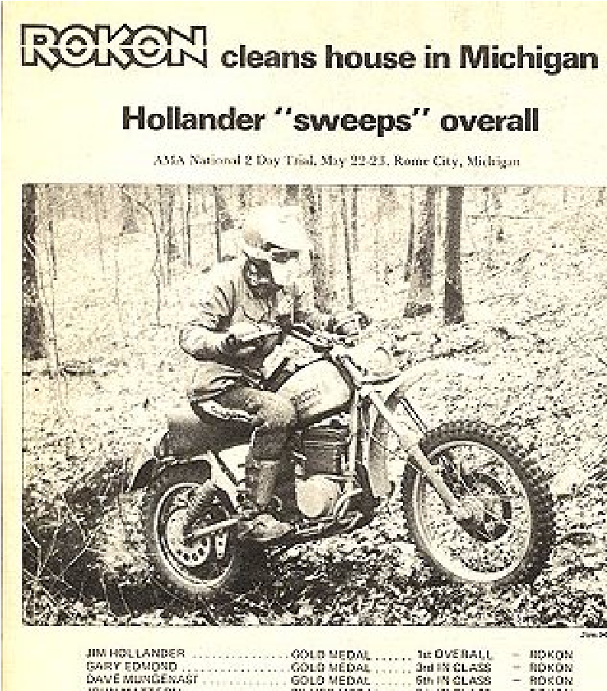

Winning Overall - US Qualifier on a Rokon 340: In 1976 I had my best racing year with Rokon. In one of the ISDT Qualifiers in Washington state, I came in 4th overall in the event and then the following Qualifier in Michigan I won 1st Overall. I think what caused me to go so fast at that event, besides reaching my prime with the Rokon, was due to an incident with the Rokon factory mechanic Marty Ray. Marty was a part time Bennington, VT police officer, full time Rokon mechanic, was somewhat rigid and we just didn't get along. At one of the Michigan gas stops, Marty put gas in my tank and only filled it half way. I discovered it at the time-stamp clock, quickly spun around and returned for gas. I was furious at such incompetence, though I later learned at one of the Qualifiers another Rokon factory Team rider Jim Simmons actually ran out of gas because of a similar incident with Marty. Anyway, when I left that checkpoint time-stamp in my "grace period" I was ripping mad, and within yards of the the checkpoint was an important special test thru the woods. I simply flew thru that special test, so I think that caused me to win the event Overall. My other times were good also, and perhaps the usual top riders just had a bad weekend. But Jack Penton and Dick Burleson were there, so I was

pleased. Marty managed to let me overhear him remark, "Why did it have to be Hollander that won overall?" He was both happy for

the first and only Rokon Overall win at such an important event, but was bummed that it was me. I drove home kind of depressed and

disappointed too, as Marty managed to say a few nasty things to me reminding me that the factory was "going to stop supporting me

just before the Michigan event, and this win didn't change things".

Rokon unable to finance 2 of us for the Austrian ISDT 1976: Later that summer, Rokon had serious financial problems, and they couldn't afford to send Connecticut rider Gary Edmond and myself to the ISDT in Austria. Because of my 1976 Qualifier performance, I was put on the 6-man Trophy Team with my Rokon. It was a mixed team with 6 different brand motorcycles. It was informally established that the Rokon was the weak link on the Trophy Team that year. Rokon sent no factory support people, and Gary and I had a little trouble getting one of the other US support manufacturer teams to take care of us at the gas stops.

However, Bultaco's support team came thru for us taking care of gas stops and checkpoint food and drinks, so both Gary and I got Gold Medals. I ended up as the top scoring USA Trophy Team rider and 6th American. The most reliable bike was thought to be a KTM ridden by Kevin Lavoie, but his bike broke with engine problems, and he did not finish. Although Rokon couldn't afford to send me to the Austrian ISDT, I received a generous gift from a New England motorcycle woods riding club who raised the money to enable me to go that year to Europe. Although I did well there, it wasn't without incident. Trophy Team Manager Marcia MacDonald explained in a motorcycle publication: CYCLE NEWS:

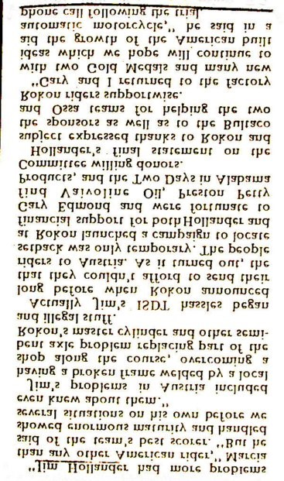

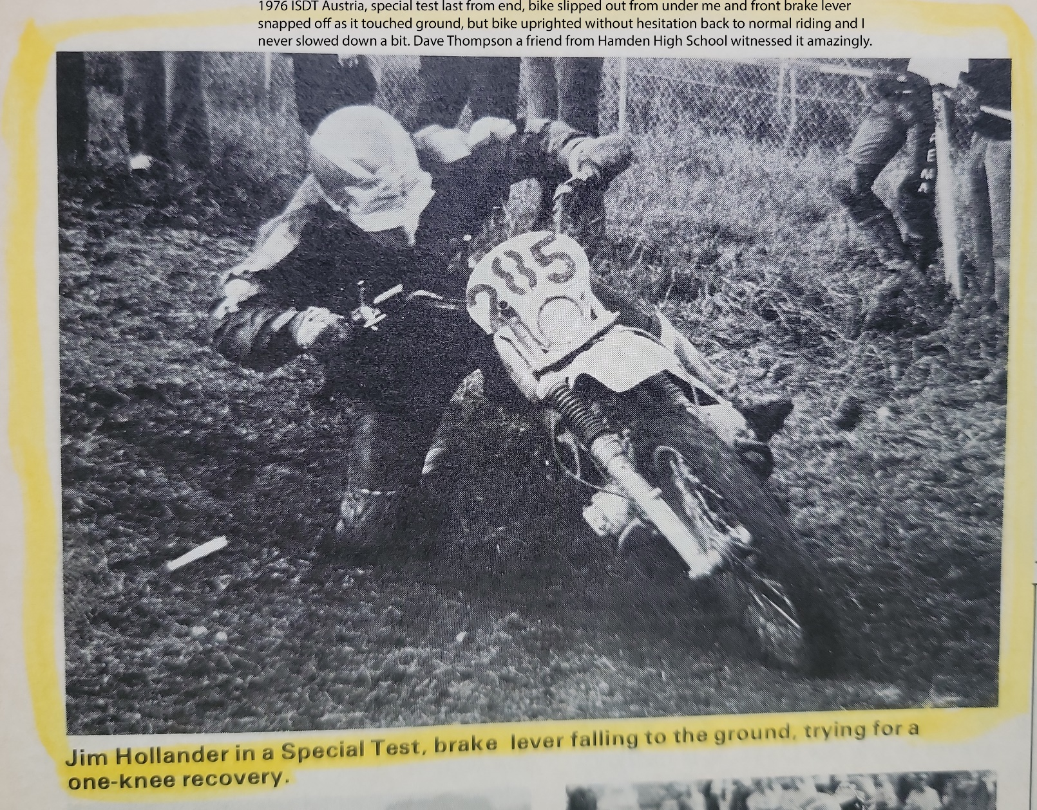

On the 1st day I clipped a tree with my handlebars and had a bad crash where the side crash guards ripped out of the frame and left two holes in the frame down-tubes. Basically I had a broken frame and it was not going to last the 6 days like that. At the next checkpoint I quietly told the USA support people, and they planned to quickly find some oxy-acetylene welding tanks to set up a deep-woods repair. Dick Mann, former National Motorcycle Champion who had some ISDT experience, was there in the support team that year. He got all set up to meet me to weld my frame, but before I learned that they had set that up, I had already fixed it. I was riding on what I knew was a relaxed time schedule between two checkpoints, and I spotted a public-works garage with lots of trucks and snowplows out front. I could see they were inside arc-welding, so I rode in, pointed to the frame damage, and although I couldn't speak the language and they didn't speak English, they knew what I needed and got into fixing it. I never got off the bike while they welded. I thanked them and they all smiled and sent me on my way. They refused any payment from me when I motioned to look for some cash. At the checkpoint the US support team started to explain to me the arrangement to weld my frame up in someone's garage, hidden from view of the course Marshalls. Help like this would get you disqualified, though it was extremely common for this kind of illegal assistance to occur. Later in the event, I managed to bend my front axle badly enough that I had to replace it. But it was really stuck in the fork tube hole. A group of energetic support people rented someone's garage on the road route, directed me inside as I approached, and closed the door down very quickly. They pounded out the bent axle with a sledge hammer and a big drift pin, replaced it, and I was ready to go. But when they slammed down the garage door it locked and they couldn't figure out how to unlock it. One of the big guys there was preparing to break it down to get me out quickly, but fortunately someone figured out how to open the door and I was back on the day's course.

At Rokon in New Hampshire I shared an apartment for a time with Jon Stillman, who also worked for Rokon and was always with us when the team went to a US ISDT Qualifier. We got along well, but he was working as Marty’s assistant (washer-filer that he was), so he often asked me to cut Marty some slack. Marty and I once got into a rolling-in-the-dirt fight at the end of one of the ISDT Qualifiers. I was running behind schedule coming into the final Day 2 checkpoint, where the riders then had to ride in a final special speed test. Marty could be pretty cruel at times, and this time he decided he wasn't going to wait for me to come within my allowed bronze-medal hour at this last checkpoint on Day 2. When I got there Marty was just finishing putting everything away in the support van, like snacks, water, gas cans. We came together like a magnet fighting and rolling in the dirt. Marty was fixing to abandon me at this final check-point and special test. I got so angry at Marty that I paid my own way to fly back to New England just to avoid driving back to the factory with him in the support van.

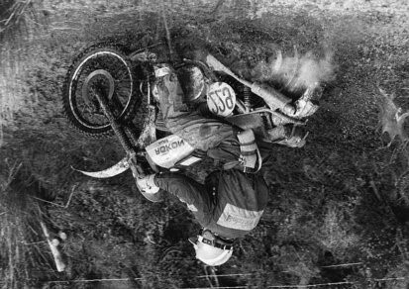
Jon Stillman was working for Honda Motor Co. USA, and I once saw him at a motorcycle Expo. He moved his way up the ranks to be Manager of Accessories for Honda. Since I knew him, I once contacted him to ask him if he could consider and evaluate my Hot Grips® for purchase by Honda. At the time I contacted him, I was already a Yamaha OEM supplier of heated grips, so I felt OK about asking him. He turned me down flat and abruptly with "No one wants to put heated grips on their motorcycle...you're dreaming". Jumping ahead a number of years, Jon no longer works for Honda as Manager of Accessories, and heated grips are available for their touring bikes either as original equipment or as an option. And heated grips are available on most bikes. (Honda, Yamaha, Suzuki, Ducati, Harley Davidson, Kawasaki, etc. all sell heated grips.) There were dozens of heated grips on the market eventually, even a company in China that called their product HOT GRIP. Another Far East manufacturer put the words "HOT GRIP" on their heat control box. Even KTM was caught selling an orange carded set of heated grips with the words "HOT GRIP" on the control box. I sent the USA importer office a certified letter about the trademark infringement, and they ignored me. A company in Nebraska was selling Taiwan made heated grips and called them Hot Grips on their control housing. They appeared as a kit available for Harley Davidsons in a Police Equipment catalog. I did more than just threaten over that one, I sent a formal Trademark Infringement complaint to the US Customs Dept. and let them take care of it. One of my Hot Grips® wholesale distributors even got into the act selling copycat "Hot Grips" made in China. It was with some satisfaction that I heard from a dealer in 2012 that Honda’s ST-1300 touring bike heated grips were failing at a large rate. Honda covered them under warranty but they gave up on making another design, announcing there would not be a new one.

I always was very fond of the Rokon 340cc motorcycles and still had a collection of five of them in 2023. After I left the factory with the motorcycle, I tried a Hercules 7-speed motorcycle, fitted it with a Rokon front brake disc, but during the first event with it I was missing the automatic too much, and gave it back to Hercules. I went on to UMASS to study engineering. Rokon brought in New England riders George Peck and Randy Martin, both of whom won New England Grand Championships for Rokon. I learned years later that the Rokon factory also had those two riders title and register their race bikes, and both took their bikes home with them in the end, when they moved on to race a different brand. Go here for more Rokon 340 images: https://www.facebook.com/groups/370800536301273

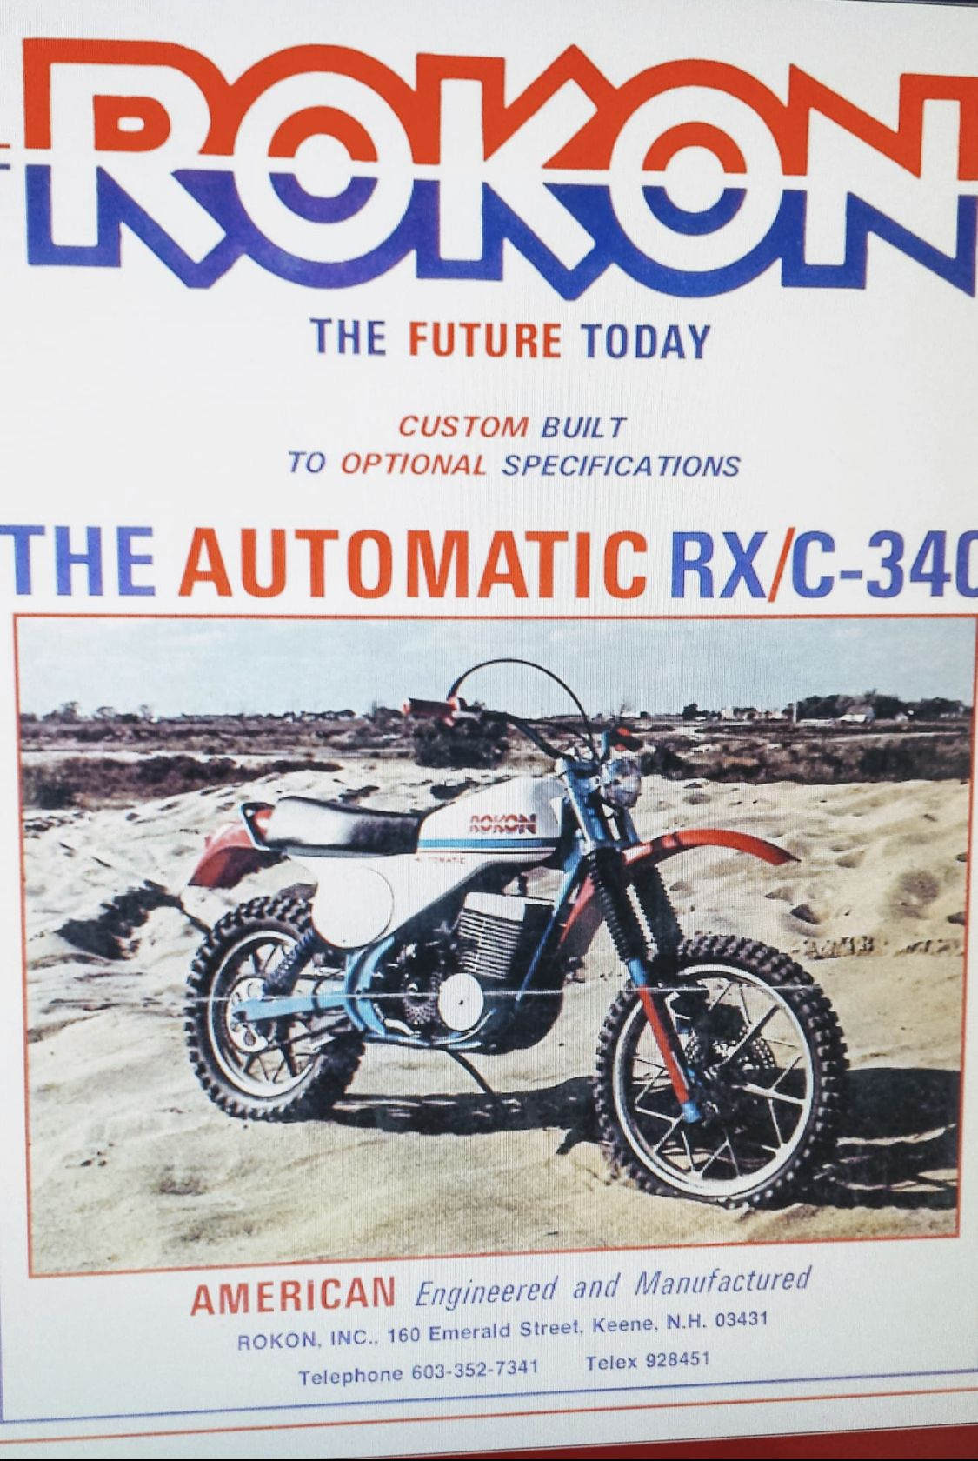
Rokon Motorcycle Factory goes Bankrupt: Rokon ultimately went bankrupt and sold off one piece at a time at public auction in February 1978, where I bought a one-off prototype Rokon 501cc bike that the factory had Doug Drussell build for them. It was hand-built but looked ‘factory’, it was that nice. It was to be their next new model but they didn't stay alive long enough to produce it beyond the prototype. It had an aluminum gas tank under the seat to lower the center of gravity, the air cleaner was up under a fake gas tank shell, it had the countershaft sprocket directly on the swing arm axis line so the chain didn't tighten up as the suspension moved. It had a rear disc brake mounted "inboard" on the same line as the countershaft sprocket and swing arm axis, and a Maico 501cc top end was mated to a Rokon Sachs 340cc bottom end. The gear-reduction box had a different ratio and was handmade like most of the bike. It was a marvel to look at the detail that went into it. The Rokon factory never paid Doug for his work, and Doug went on to build famous farm tractor drag racing machines.
I went to the trouble of taking the unique fiberglass outer shell and Chuck Hemlow of VT spend weeks making a mold from it, so I could make a duplicate and save the original from damage. At the 2023 50th ISDT Reunion, the image below is how the bike looked at the event. It had many innovative unique features fabricated by Doug Drussel, it was an exciting concept.
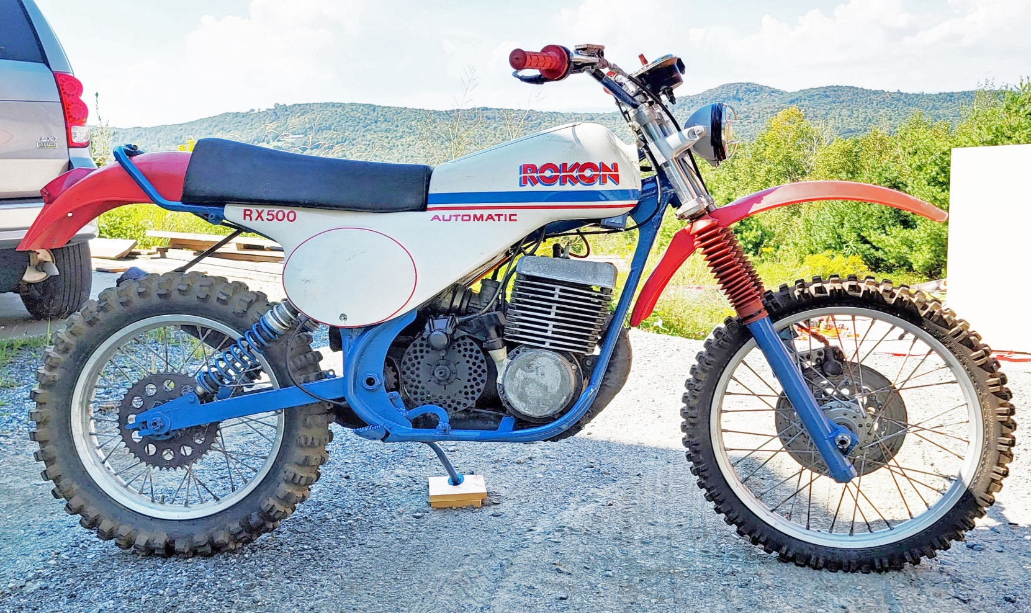

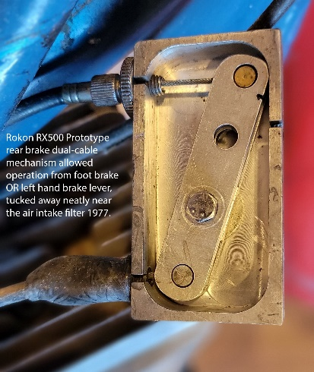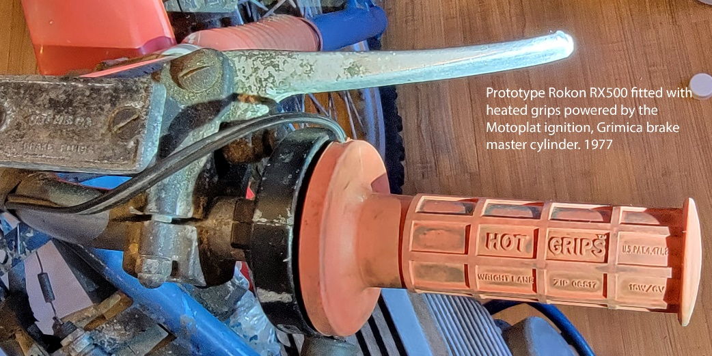
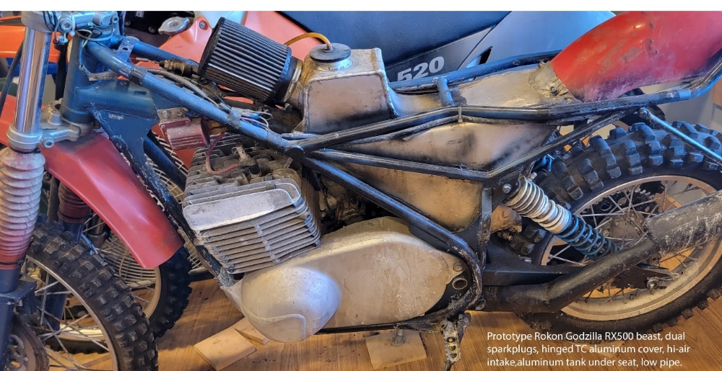

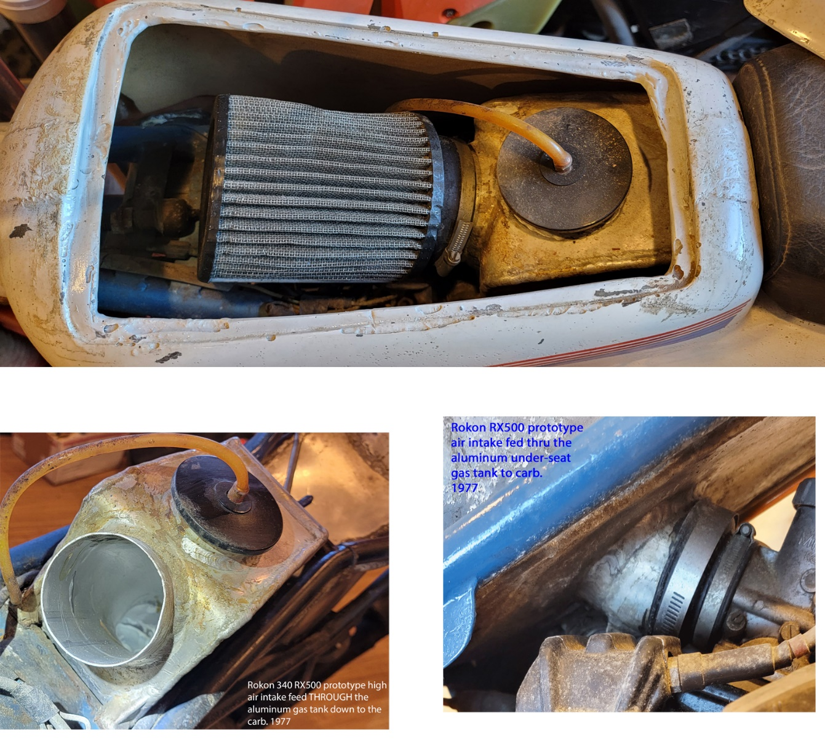

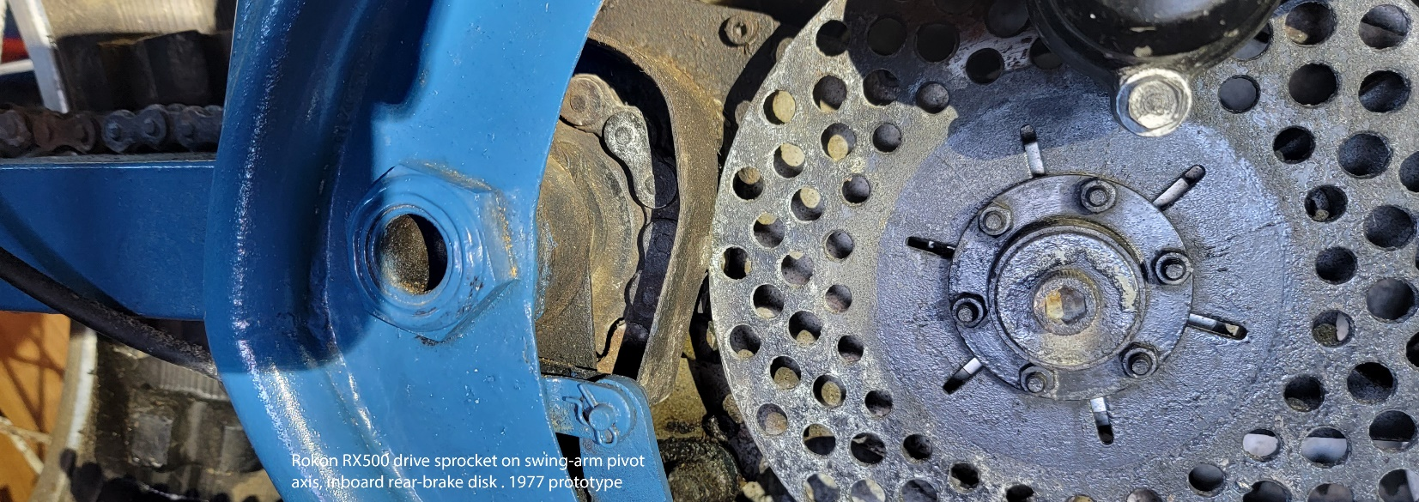

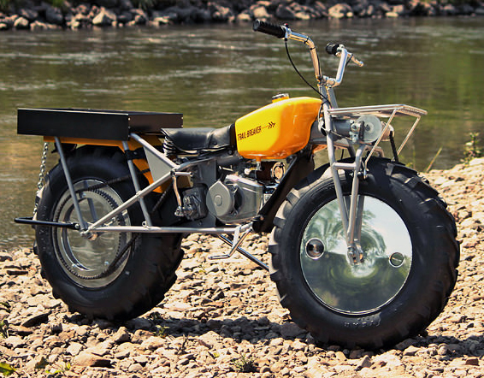 Rokon 2WD Trailbreaker.
At the bankruptcy auction I also got ten partially built 2-wheel drive Trailbreaker® machines (shown above) for $140. each, bought the missing parts from the various buyers after the auction to make whole machines, sold them for a 700% profit and raised enough to help pay for engineering school at UMASS. The Rokon two-wheel-drive explorer type shown here:
https://www.google.com/search?q=rokon%20motorcycle%20for%20sale&tbm=isch&rlz=1C1CHBF_enUS1011US1011&hl=en&sa=X&ved=0CCEQtI8BKAFqFwoTCOi-17bKs_8CFQAAAAAdAAAAABAF&biw=2099&bih=985&dpr=1.83
Back in 1977 when I started the 4 yr. program the semester tuition for an in-state resident was $400. That'll never happen again unless you go to Cooper Union in NYC or get great scholarships. (All students at Cooper Union pay no tuition.) The profit was also used to pay for the first injection molds necessary to go into Hot Grips® production. I needed a place to build up the ten 2-wheel drive Rokon Trailbreakers® and my enduro longtime friend, Rokon rider and motorcycle dealer Jerry Randall who owned Valley Motorsports in Northampton, MA helped me out enormously. Jerry and his wife Cindy often took me to New England enduros, stored Can-Am 250 and 370 enduro motorcycles for me at his motorcycle shop as I tried to dabble in enduros in the early 1980s. He allowed me to work on my cycles at his shop when I needed to, was a constant business advisor whenever I needed his opinion. One year we both went to Great Britain stopped at the Can-Am factory and picked up a couple of motorcycles, using them while attending the British ISDT in Wales, and then afterwards the Can-Am factory shipped them to Jerry's motorcycle dealership since he was a Can-Am dealer. Jerry went on to win the New England Enduro Championship in multiple years while I was growing the Hot Grips® business. He stayed with enduros for an incredible number of years, managing to keep in shape and doing very well in his business too. Recently I was told he gave up enduro competition and switched to road-racing (track events) riding a Yamaha R6.
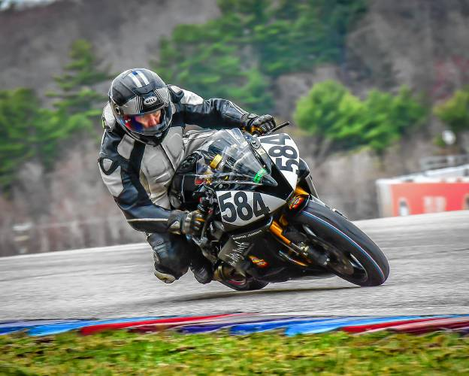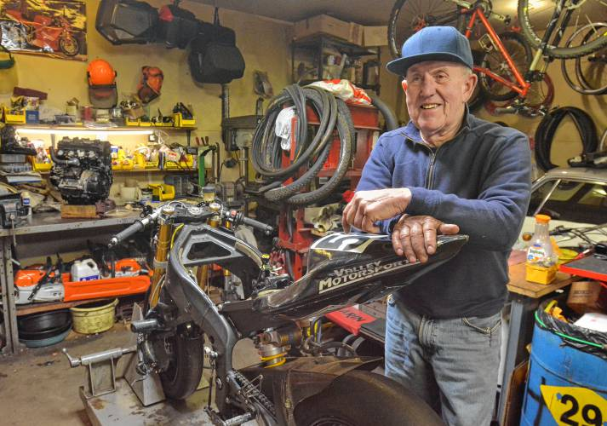
I absolutely loved racing in these long events thru the mud, rocks, hills, streams, you name it, they ran us thru it. But I had a problem when it was cold, my hands would get numb, and the only way I could keep riding when it got raining and nasty was to put my hand on the bike's exhaust pipe while I rode. Of course, this was only possible in the woods on the clutch side. On the throttle side I did it only when I was on a section of road, not in the woods. Most riders did it that way. They would reach over and operate the throttle with the left hand, and the right hand could be put down on the side of the engine fins. It was kind of goofy looking, a convoy of riders all covered in mud riding in single file up the road with their hand on the engine fins, operating the right throttle with their left hand.
I tried cartridge heaters in 1976 at the Austrian ISDT where they helped to keep my hands warm in the rain and at high altitudes. The same small electrical power that fed the headlight could be switched over to the special 6 volt heating cartridges I bought. We had to have working headlight and taillight in these Qualifier races so I had a 3-position switch to change function to operate the required lights. The ISDT is a 6 day long motorcycle endurance event that often takes you into cold conditions, even snow at times in the higher elevations. From 1976 thru 1980 I spent countless hundreds of hours working out various designs, (still have the 7 spiral notebooks in my office as a reminder. ).
Cartridge Heaters and Printed Resistance Heat Circuits: After cartridge heaters I tried printed resistance circuits under the grips on street motorcycles but too much of the heat is lost to the handlebars which act like a heat sink, especially with the thick Italian Gran Turismo street grips of that era. Then I studied the various resistance wires available (there are hundreds of alloys with different characteristics). It was common knowledge in the industry that nearly always the printed-circuit type of heating elements would develop a hot spot which would eventually burn out like a fuse. There was a terrible reliability record of Ski-Doo snowmobile OEM heated grip circuits. One customer reported online he replaced 4 Ski-Doo heating circuits in the first year of his new snowmobile. And for motorcycle use they are even less reliable because there is so much stress on the wires on the throttle side. They are not manufactured with any wire strain relief, so the wires break where they are soldered to the circuit.
Ohm's Law Formulas: I spent countless hours at the UMASS library and learned about the various electrical formulas.

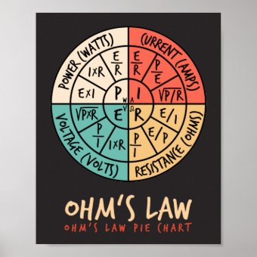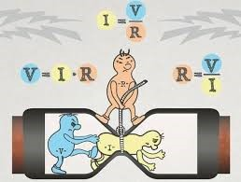

Civil Engineering homework assignment became a design for heated grips: I had raced endurance motorcycle events for 8 years, but knee injuries and surgeries eventually put an end to it, so I decided I wanted to be a mechanical engineer and went to a 4 yr. program at the University of Massachusetts in Amherst. I had a civil engineering course in my 2nd year where we were spending a lot of time learning mechanical drafting techniques. The professor had a homework assignment for all students to submit the various 2D and 3D angled views of a piece of furniture. I asked the professor if I could demonstrate the same skills with drawings of a heated grip I had long been contemplating, and he said OK. I really went to work on details and got to a point where I felt I could actually manufacture them. The next step was to take a machine shop course where you get to learn how to run milling machines, lathes, & surface grinders. I loved this course, and when given the opportunity to do something on my own in the class I chose to make a single cavity mold to create a heating element polymer cylinder, to begin the process of making a heated handgrip.

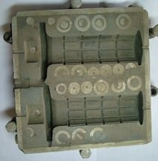
Learning about Injection Molding: I studied injection mold tool-making at the library, there was no internet. And I learned a great deal about thermal expansion, shrinkage factors, and injection molding machines. This went on so much that I was working 14-18 hours a day on it 7 days a week. The machine shop professor was extremely encouraging and allowed me to come to the machine shop between my classes to continue work on the mold cavity set and the molding-cores. This went on for many months. Next was a visit to the Chemical Engineering Dept. at UMASS where they had a small vertical-clamp injection molding machine that wasn't for production but demonstrated the principles of injection molding. I spoke at length with the senior student in charge of the injection molding lab, and he invited me to bring my crude mold in to see if I could actually mold a heated grip. The inner heating element of the heated grip was the biggest challenge because I needed to have a 6-foot-long resistance wire trapped in one position while the very high injection pressure shot melted-polymer into the mold. The pressures were very high and they would push the coil all to the opposite end of the cavity during the process. So I had to engineer a means of "capturing" the coil in one position while the high pressure flowed inside. I spent so much time at that sample injection molding machine that the senior student in charge of the lab spoke to his professor and got the OK to give me a key to the lab, so I could come in at any hour of the night to work on experimentation and solving problems. Above is the mold of the OURY grip that would accept my resistance heating element, OURY being a popular offroad design.

Solution to Making the Heating Elements: The solution involved a very accurate pinching technique where the coil was held in one position from both inside and outside while having flow passages everywhere, which trapped the wire in position. It worked great, and the next step was making a universally acceptable heated grip outer shape. This kind of expertise was beyond my training at that point, so I went to many toolmakers in the industry until I found one that shared my excitement with the project, and he gave me a reasonable price to make a professional aluminum prototype mold, one for the inner heating element and the other for the outer grip, with steel cores. It cost $5000. which was a considerable amount in 1980. A new VW Beetle cost $6800. in 1980. The only way I could afford to do it was if I could pre-sell the product before it was even manufactured. Fortunately, I had a very good relationship with the president and the staff of the motorcycle company I had previously raced for- PENTON. And I knew all of the top endurance racers very well too. I took an OURY motocross grip and learned how to make a plaster-of-Paris mold of the grip, both halves, and eventually I got one made that did not have air bubbles trapped at the surface, good enough for a working prototype that could be used on a motorcycle.

I had no experience manufacturing a product, so I contacted a former goggle sponsor of mine: National Hydron in Pennsylvania manufactured an anti-fog set of goggles, that I used in Austria at the Six-Days. I created a test-bed with my 1973 Honda 500-4 cylinder street bike and offered to bring it to National Hydron so they could evaluate it by using the prototype heated grips. As the weeks and then months went by, I learned that they never bothered to try it out, so after a considerable time, months, I drove to Pennsylvania and picked up the Honda 500. I needed to find a manufacturer that was interested in manufacturing my invention.

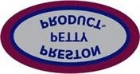
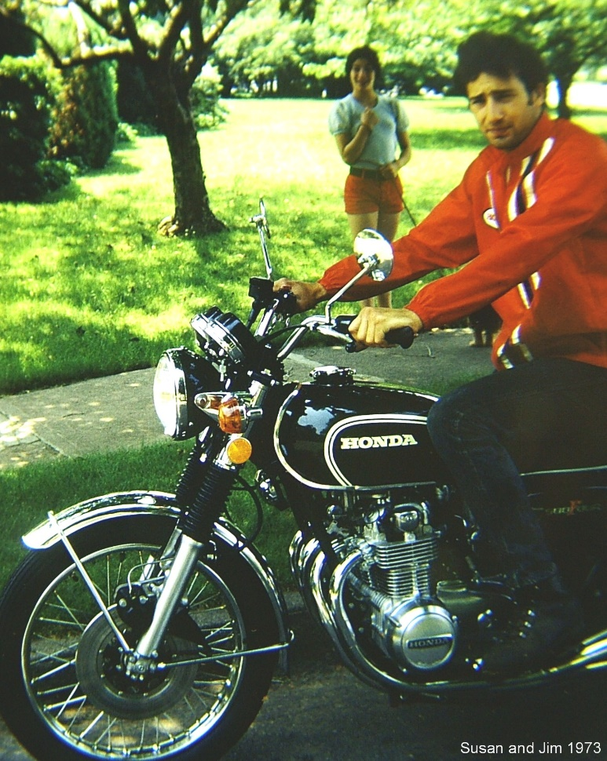

Contacting OURY Grips and Preston Petty Products: I contacted the OURY grip molding factory and spoke at length with the owner Bill Oury. I also contacted Preston Petty Products in Oregon. I knew Preston Petty from the ISDT qualifier events which were used to select members of the annual US team that got to go to Europe to compete in the ISDT. I had visited his factory when I raced once out in Oregon at a Qualifier event, and he certainly had the molding machines and know-how for it, as he was molding unbreakable PP fenders, grips, work tubs, number plates, headlights, & KTM engine cases out of injection molded plastic. Although both business owners considered my proposal, neither of them was ultimately willing to commit to the tooling costs. So I was on my own, and had to figure out how I was ever going to get my product off the ground. National Hydron in Pennsylvania agreed to look at my Honda 500cc 4-cylinder street bike fitted with my heated grips. It was fitted with the prototype Hot Grips® and an variable rheostat so they could test the heated grips. They had it several months but did nothing, so I gave up on them and took the bike back. It was good for me that none of the other companies wanted to pursue it.

At this point I was making hand-produced grips in my dormitory room, at 3 hours each grip. That's a story-in-itself! I hand-molded them in this very long process by using a prototype material called Devcon Flexane®, a mixable rubber-like material that could be flowed into my crude grip mold to form the rubber part of the grip.

Developing Prototypes as a University Student: Molding the outer shape of the grip was a huge challenge for me. Here I was, living in a dormitory room at the University, a small single corner room on the 4th floor. It was the dormitory UMASS used for all graduate & foreign students. I needed a vacuum chamber. I figured out a method of using a 8" diameter x 12" long piece of scrap-steel water-pipe I found in a junkyard, brought it to the UMASS machine shop to lathe cut it having precisely flat ends. Fortunately, I was still welcome at the machine shop. I obtained two 3/4" thick pieces of flat Lexan® polycarbonate that I machined to accurately close off both ends of the machined waterpipe. I then machined a steel chamber with a valve to introduce "mixed synthetic rubber" into the crude grip mold that was hung suspended in the center of my fabricated pipe-chamber. I installed a fitting into the pipe to enable me to draw the air out of the chamber using a vacuum pump. Now I couldn't afford sophisticated equipment like that, so I took the compressor out of an old refrigerator and used it in reverse to suck the air out of the chamber. I also used the same apparatus but reversed to create a pressurized container of air in an old Freon R12 refrigerant container. Fortunately, I had no roommate in the dormitory or I never would have gotten away with all of this apparatus.
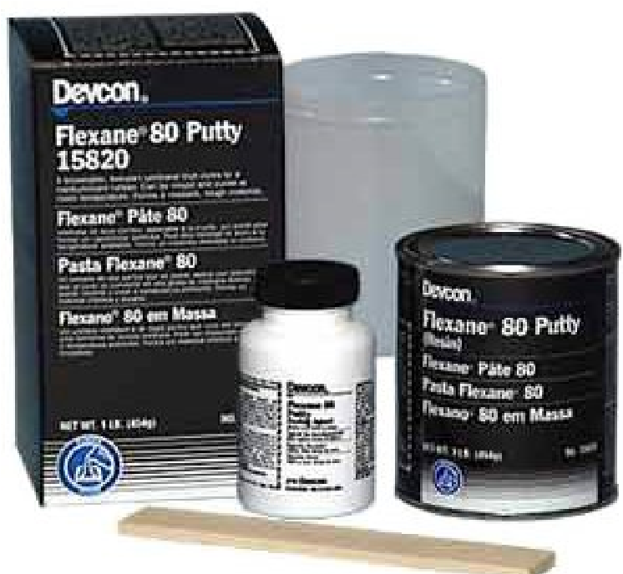

I would hand-mix the 2-part Flexane® rubber and put the mixed material in the vacuum chamber, then suck out all of the air. This would cause all entrapped air in the mixture to bubble to the surface and burst, so the Flexane® would be bubble-free. I took one of my pre-molded heating elements from the school injection molding lab, a cylindrical form that would be placed on a core mandrel inside the OURY outer plaster-of-Paris mold. Then I mounted the suspended mold in the chamber, refitted the Lexan® ends, sealing them with Vaseline to prevent leakage. I drew a vacuum again on the chamber using the refrigerator pump in reverse. I attached the chamber of mixed bubble free Flexane® rubber onto the top of the chamber and opened the valve. The Flexane® would get quickly sucked into the mold and when it started oozing out the edge of the mold, I knew it was filled. I'd shut off the valve before any air got sucked in, and allowed this to cure for 2 hours. When I took it all apart, I had a finished "injection-molded" grip in the shape of the commercial OURY motocross grip.

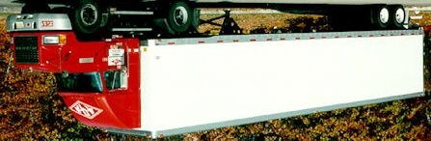
Everything was documented throughout this multi-year period at the University in spiral bound notebooks, complete with detailed colorful sketches on most pages to visualize what I was doing. I had become a very good mechanical draftsman from my engineering classes, )which turned out to serve me well in future years, as 25 years later I had a fully outfitted CNC machine shop). I stayed there during the summers so I could attend "summer classes" and be there to continue my work. I loved every minute of it, as the demands it made on me fit nicely with my obsessive nature. I took a course in Business-Management, a course in Economics, a course in anything I needed to proceed with creating a small business. And to my surprise, there was not a single class professor that did not encourage me. Eventually I rarely went to my scheduled classes and simply worked on the grips in my 4th year, in the dormitory Most of the professors allowed me to obtain course credit for "Independent Study" as I would submit reports to them periodically on my progress. There was a class on employee management I wanted to attend, but rarely made it, missed most exams, and finally when the final exam was scheduled I went to the professor and explained to him why I missed so many classes. He ended up giving me a passing grade of "D" in recognition of what I had accomplished with my new manufacturing enterprise, and I wasn’t required to take the final exam.

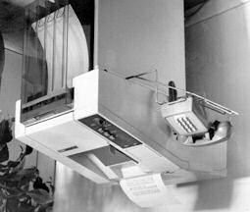
University Fire Marshall reads me the riot-act: I needed to order 50 pound bags of thermoplastic rubber, and ordered it giving my dormitory address for delivery. One day a 53’ long tractor-trailer backed up to the dormitory front door and asked about delivering several bags of thermoplastic. I was located and I came down with my modified shopping cart so I could drag the bags of plastic pellets to the elevator and bring it to my room (I had an illegal key to the elevator). The University Fire Marshall got word of what I was doing in the dormitory and eventually I received a visit and was read the riot-act over all the possible fire-hazard chemicals and boxes I had in my dormitory room. He talked it over with the head overseer of the dorm. I was given an empty storage room to store my boxes, plastic pellets, inventory, and chemicals, and was given a genuine legal key to the handicapped student elevator so I could bring the many boxes of materials up and down 4 flights to my floor. By this time I was making hundreds of heated grips per night, as I did the injection molding at late hours so as to not interfere with other normal production molding that a local commercial shop operated. For several months I would go to that local injection molding shop and work beside someone to make the grips until three in the morning. Then I’d bring boxes of molded grips to the dormitory, load them onto my special cart, and had to run the gauntlet thru the dorm TV room which existed between the entrance and the handicap elevator. There was too much for me to do each day, so I hired students on my floor to help with 100% electrical quality control & visual inspection to sort out the rejects. The reject rate was terrible ranging from 35% which was excellent to 85-90% which was very discouraging. I was determined to fill that first order of 2000 sets by the end of the year, but I actually met the Penton delivery deadline. I finished my 4th year without getting my Engineering degree, but it didn't matter, because I was now in business, contacting motorcycle manufacturers and motorcycle parts distributors all over North America and Europe. This was before the days of the reasonably priced FAX, it was all by snail-mail. I remember in 1984 my first fax machine cost $1500. Now 39 years later they’re $50. and are obsolete in view of email.

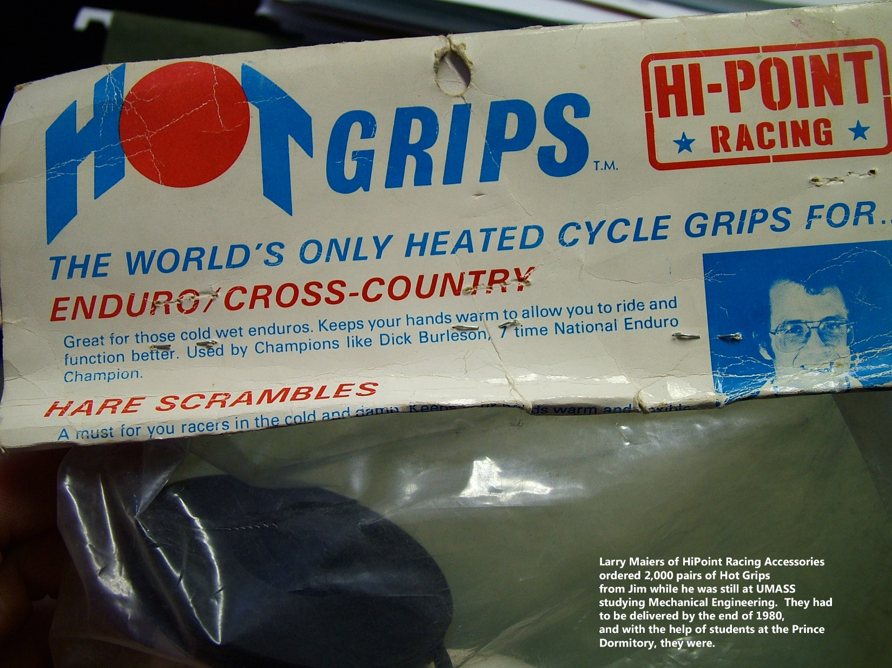

Copy Cat Product from the Far East. During 1981 my snowmobile model came out, which sold like hot cakes for many years. My early distributor Parts Unlimited brought in 5,000 look-alike sets made in the Far East. My utility patent was still pending. They were selling them wholesale to dealers at half my price. The Taiwan manufacturer copied the patented internal heating element, even the texture on my grips was duplicated, but left my Trademark off. Fortunately they manufactured them with the wrong alloy resistance wire for the bike’s available voltage. They wouldn't heat up very much, and never surfaced on the market again. In reality they used 12 volt wire, instead of 6v wire. They could have instructed the customers to wire them in “series”, but instead told them to wire them in parallel, so there was only 25% of the heat. They were not bright enough to catch the error in the installation instructions, so I kept my mouth shut.
Top Overall ISDT - USA Team rider & heated grip prototypes in 1982: In 1982 I went back to the ISDT as a "spectator" and USA ISDT team supporter, and drove a rental car to the MAGURA factory in Germany. I met with a number of MAGURA managers and engineers at a big conference table. I was only two years in business at that point, was very naïve in business, and I proposed that I make heated grips for MAGURA to supply BMW and other cycle manufacturers. I left them a set of my heated grips. They stated they had their own heated grip design which consisted of a resistance wire sewn to a cloth backing in a serpentine pattern. They were suffering from resistance wire failure. They were impressed that I was having no such failures with my double-helix injection molded heating element. I never heard from them again.
In 1984 I went back to the ISDT in Europe with lots of production heated grips and invited the whole US ISDT Team to fit them, though less than 10 took me up on it. They were probably right to not take a chance as their hands might get blisters using a new grip surface that they were not accustomed to. Consistent with the way manufacturers looked at the ISDT, I took special care in manufacturing these grips, and they were all molded in a specially ordered white rubber material. One of the 2 years I was there with product, the top American rider at the Six-Days was a guy who went on in 2011 to be the rider with the world’s most ISDT starts and finishes (26) ever: Jeff Fredette. Jeff Fredette ultimately (as of 2023) has the most ISDT events of any rider in thre world. I also located the ISDT overall top rider, who rode a Husqvarna, and gave him a set to evaluate in Sweden. I received a postcard (of him standing next to a Husqvarna) months later and he loved the heated grips, but I could tell from the content that he expected me to offer him big money to use his name endorsing the product. So that did not work out. However he gave me a gift of his Swedish Husqvarna riding jacket while I was talking with him at the Six-Days event, which I still have to this day.
Immediately after returning to the US, Jeff Fredette’s use of the heated grips inspired me to run a congratulatory advertisement with a photo in the Trail Rider Magazine. But the $600 expense didn't result in a single sale, so for years later I did very little advertising. It has mostly been word of mouth selling, or a display in a wholesale distributor catalog. And now the Internet website is our only advertising.
When I moved out of the UMASS dormitory I ran the manufacturing out of a 2 bedroom apartment near the University, where I set up a tiny 120 volt “machine shop” in an old Dodge van, with a South Bend Lathe, drill press, air compressor, and grinding wheel. Next, I rented a house with a 2-car garage nearby. Then into a mortgaged first home where I installed a new 1983 Battenfeld 75 ton-clamp Injection Molding machine. It required 3-phase electrical power so I converted the single phase 240 volts over to 3-phase using a 600 pound rotary phase converter. I needed water cooling for the injection molding machine, and diverted a local stream flow thru a buried pipe into the building. After a year at the first house, sales were so huge that I had to find a bigger business location. I purchased a home/business setting where they already had a complete machine shop and 2 injection molding machines. I had learned a great deal from this injection-mold shop-owner: Joe Gagnon. The owner had suffered heart problems and was giving up his business, so I paid his asking price at $108k and continued growing my business. I added a new Battenfeld 50 ton clamp molding machine and bought his 100 ton toggle-clamp Italian MIR molding machine. The MIR already had a big contract making Brine brand plastic shin guards, so we just continued to run that product alongside our own. I took over the lease payments for all the machine shop equipment, so had a full machine shop.

Making OEM snowmobile heated grips for YAMAHA of Japan: While in Massachusetts, an engineer contacted me and suggested we meet about making heated grips. At my kitchen table, he brought out detailed mechanical drawings of my grips which offended me, since I felt they were just pumping me for details so they could make them in Japan. I halted our meeting and brought him to the airport for him to return to his Georgia USA office. But later two more engineers from Yamaha Motor Corp. of Shizuoka-ken, Japan visited to discuss our making their snowmobile heated grips. This time I was more polite and accommodating. They had made their own heated grips for a few years, but they were unreliable and they couldn’t solve the problem. After 2 years of visits we started shipping 1,000 pound gaylords of heated grips by ocean freight to Japan, where they were installed on the sleds and then mostly shipped back to North America. Nearly every year Yamaha engineers would come to meet with me and check out our production methods, all the time taking detailed notes. This went on for over ten years.

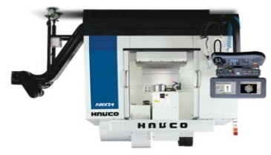
During 1990-2001 as OEM supplier for Yamaha, we were told we did not have a single defective heated grip either electrically or cosmetically. I was invited to attend a special ceremony where I was to be honored at the Japan Yamaha factory headquarters, but the disruption to business and the expense to fly to Japan did not appeal to me, so I declined. (Much to my regret in later years...I'd still like to visit Japan one day.) The Yamaha engineer stated that we were the only company that made parts for them that had a flawless quality-control record for ten years running, including the many Japan based suppliers. I learned a lot working with Yamaha, and went on to supply original equipment heated snow-thrower grips for Ariens, John Deere, Sears-Craftsman, Wire-Tech, Snapper, & Simplicity. I didn’t know they were going on the Sears snow-throwers until I saw my heated grips on Moving the Manufacturing Business and Machine Shop to New Hampshire: After 4 years in Massachusetts at that well equipped business location, I decided to move to tax-free New Hampshire in 1989. (NH state motto is "Live Free or Die") The 100 ton toggle clamp Italian MIR molding machine was sold to the first tool-making company that I had hired years ago. About that time we had the 80,000 defective Gaynor electric-switch problem, caused by an unethical supplier from CT. It took some convincing of the local town's Board of Selectmen to allow a variance to zoning, but with several meetings I was allowed to run a "home business". We installed 4 new Japan-made Shinwa Seiki computerized injection molding machines and a later a 110 ton clamp Toshiba. We have been here in NH the last 34 years. We currently have a full CNC machine shop with a wire EDM machine, 2 sinker EDM machines, 3 vertical machining centers with automatic tool-changers (one with a programmable 4th axis table) surface grinders, an ID-OD grinder, 75 ton metalworking press, TIG and MIG welding, and a CNC lathe. The injection molding shop has 5 computer controlled injection molding machines, all purchased new. We had 7 injection molding machines at one point, so retired the original two Battenfeld machines. During the 34 years in NH we slowly built up the location with 4 new buildings to run the business activities. We have a large 240v 3-phase Caterpillar diesel generator for the winter ice storm season. Of course the rule is when you don't have a generator you lose power for a week in the busiest time of the year, and when you do have one the power never goes out. The Caterpillar 3-phase generator is collecting dust. We had so many machines going at once that we suffered with severe voltage drops, requiring the utility company to install a 400 amp pad-mount transformer near the injection molding shop. The transformer dropped a 7600 volt power line down to 240 volts. Our pond was piped with polyethylene water pipe and circulated non-toxic antifreeze year-round to cool the machines. We installed our own test track on the 15 acre site for testing snowmobile, ATV, and dirt bike heated grips, and acquired an adjacent 32 acres.

Dual-Lens Electric Anti-fog Faceshield Patent: In 1986 in Massachusetts, I developed prototypes of a dual-lens anti-fog heated helmet face-shield. The inside was printed with a number of horizontal lines made of a conductive ink, and when 12 volts was applied, regardless of the humidity level - the lens was fog-free. Soon after I obtained my USA 4,682,007 and Canadian 1,273,383 utility patents on the electric face-shield, a near identical model started being manufactured by SEER in Canada. Prior to my obtaining my Canadian utility patent, a Colorado based face shield manufacturer phoned me and introduced me to their Canadian branch Ontario counterpart, and that I should expect to hear from Doug Reuber about my electric face-shield. The Canadian company led me on with interest in my invention, and shipped me a large box of dual lens face shield to experiment with. I had sent prototypes up to them with discussion of a royalty arrangement. All of the technology was revealed to Reuber in faxes and telephone calls. The Canadian company’s owner ended up applying to the Canadian Patent Office for the same electric-shield, and the text in his Canadian Patent curiously was identical to my earlier issued Canadian Patent, word for word. How could that possibly slip by the application examiner? I hired a second legal firm in Canada and went after him, but the Canadian Patent Office was very uncooperative. How could the text of an existing Canada patent be lifted verbatim and appear on a later Canadian citizen’s granted patent … without a single correspondence with me or my legal counsel announcing a conflict or potential dispute? Yet here they were, duplicate language in each of these Canadian Patents: 1273383 and 1285976.

Canada’s Patent Office explained that they were aware of my patent, but the Canadian’s law firm pulled the wool over the examiner’s eyes, and unbelievably got away with it. They claimed Re:Fry which muddied the waters. Back in the 1950’s there was a legal case in Canada involving a man by the name of Fry. Somehow this paved the way for this outrage to take place. The Canada Patent Office then claimed they had “no power to retract or cancel a patent once it had been granted, even if now there were two identical patents. HELLO, does this make any sense? Was the Canada application examiner bribed or was he a close relative of the Canadian creep that arranged for this? Or was the Patent Application Examiner just a total idiot! They invited me to place a huge deposit with the Court in Canada if I wanted to officially challenge the Canadian Patent Office’s acknowledged error. Their admitted error was simply that they failed to declare a “conflict”. That failure resulted in Canada’s Patent Office granting a duplicate patent so that two people had the same patent under two different patent numbers. Seemed like the Canadian Patent Office was very biased in favor of a fellow-Canadian citizen and did the Ontario based applicant a huge favor, looking the other way at every opportunity they could. To this day I have kept all 43 pounds of paperwork associated with this Canada farce. Doug Reuber went on to apply, and acquire further Canadian utility patents, which suggests I was just being used as a stepping-stone to his own aspirations as an inventor.

Royalties on the electric face-shield at that early stage did not justify spending “mega-bucks” dollars in attorney’s fees. Years after the USA patent and Canadian patents expired, and I was no longer earning royalties, the same electric face-shield that I had earned royalties on from, an Idaho firm surfaced in a Parts Unlimited wholesale catalog. It looked very familiar so I ordered one. The Korean manufacturer was still packaging them with my name James Hollander and my patent number on the shield. The Idaho company claimed that the Korean company must have been making them from the original tooling without permission, very typical of the Far Eastern manufacturing companies.

British Company adopts my Trademark and starts selling throughout Europe: In the late 1980’s a Great Britain motorcycle luggage manufacturer by the name of Oxford Products arranged for their Chinese manufacturer to make heated grips, & had colorful display packaging, calling them “Hot Grips”. I didn’t have a British Trademark, and sales of my USA made Hot Grips® in Great Britain was very low. Since I had sold a large number of Hot Grips® to an English motorcycle luggage manufacturer called Opal Luggage as early as 1981, and since Oxford Products had not even started in business until years later, on the face of it they had adopted my USA product trademark. But I had no legal case against them as long as they didn't ship them with that Trademark name to the US or Canada, where I had held trademarks for years. Oxford Products began selling them in the USA under the name "Heaterz" and continuing to sell them in Europe as “Hot Grips”. They eventually applied to the British Trademark Office and the European Union for their own identical trademark.

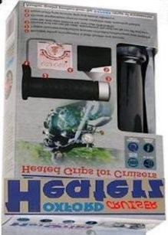
In 2006 they apparently applied to the Great Britain Trademark Office claiming “Hot Grips” as a British Trademark. They followed that with a quick application to the European Community for the same trademark, and that all happened before I even got wind of it. I had noticed a box of Oxford Products Hot Grips® for sale on eBay by a European seller. A close-up view of the packaging had the ® designation and they called them “The Original Hot Grips®” so I bought them and had them shipped to the USA. I then learned of the British and European trademarks that had been issued. I documented all of my chronological evidence and put together a bulletproof presentation, complete with a 1981 review article in a British magazine called Motorcycle Mechanics. There was a full page review of my Hot Grips® and Opal Luggage was an advertiser in that issue.

I managed to locate a seller of old classic motorcycle magazines in Great Britain. I contacted him and obtained an original of the entire 1981 issue that contained the article. I sent a very comprehensive package to the Great Britain Trademark office and they weren't the slightest bit interested The fact that Oxford Products began proclaiming themselves as the "Original Hot Grips" and copied a foreign Trademark that had been sold in the British marketplace meant nothing to them. Ultimately, I got a little satisfaction when they had to do a public product recall due to a manufacturing defect. And they still had to label their product "Heaterz" in North America. There was rule in Great Britain trademark law that forbid taking a product’s name that had been sold earlier in their country (in contrast to U.S. Trademark law that required applicants to sign a declaration that the proposed trade name had never been used in the USA.
Snowthrower Manufacturers express interest:
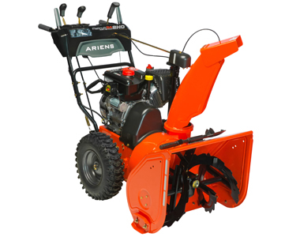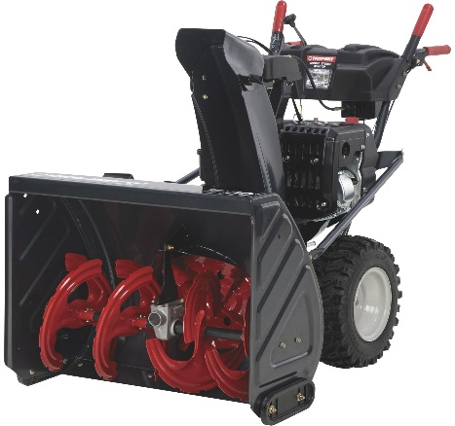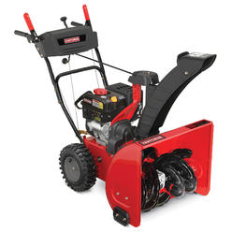
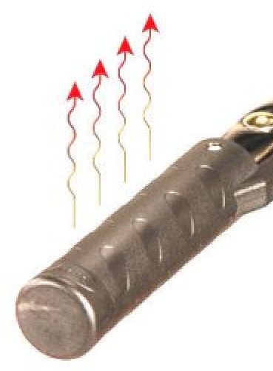
USA Snow-thrower Industry discovers Heated Grips are the Hot Ticket to sales: Ariens Company asked us to make a new design for their snow-throwers, and we manufactured for them as an OEM supplier. Eventually Ariens found a new source of lower cost heated grips in Germany, from Magura GmbH. However, our many years on the Ariens machines led to a number of OEM contracts with other USA snow-thrower companies. By now 4 of my original 5 utility patents had expired. One year the Simplicity Company reduced the quantity of heated snow-thrower grips they ordered, and I got a call from a friend that saw a Magura heated grip on a Simplicity snow-thrower at his local dealership. He sent me a photo of it and they had copied even the same wire-exit shape that I had used to supply the various snow-thrower manufacturers. I guess they got a better price from Germany back when the US dollar was strong. Now that the US Dollar has fallen in the world, I expect to be making lots of snow-thrower heated grips fairly soon. In 2011 searching on the internet I came across a blueprint in Chinese with my company name on the bottom as having “approved it”, and it was a knock-off of my heated snow thrower grip with one of my customer’s part number on it. Though totally inappropriate, they advertise them as “lawn mower Hot Grips”. Another Chinese company advertise their knock-off copy of my snow-thrower grip for motorcycles.

The Ariens

The ARIENS Snowthrower Company needed 12 volt heated grips as original equipment on their line, and Hot Grips® became their supplier for many years.
Canada Snowmobile Manufacturer SKI-DOO needs heated grips: My wife (and Production Manager) Peggy reminded me of the time when we spent 24 months working with a manufacturer in Quebec, Canada. We wanted to gain Ski-Doo as an OEM customer for snowmobile heated grips. My notebooks on that are 4" thick, and I've kept them in my office as a reminder to use caution for any OEM customers in the future. Every time they asked us for information or samples we gave them everything that they wanted. Everything was "quickly" for them. At one point their engineers sent me a unique design, a bizarre wet-dream one of them had, to make installation on the assembly line much faster. They asked me if I could make such a grip. That was towards the end of one week. I and another machinist worked on it throughout the weekend and on Monday shipped them a prototype of exactly what they wanted. I had to sacrifice one of our spare injection-molding hardened-steel cores to do it, and put a really big effort into it working deep into the night. I expected a very impressed engineer or their purchasing agent to phone me or at least fax me about how much they liked our capabilities. I did not hear from them. Finally, when I phoned them I was told that the idea wasn't totally practical because of the machining costs of their handlebars to accept the special heated grip. Their requests continued month after month, they needed heating/time studies. We thought so surely we were going to supply them that I spent $9,600 on having two injection mold tooling sets built so we'd be ready to supply them quickly with a design just for them. Again samples were sent up to Canada and I did not hear from them. Their contact with me slowed down and I finally phoned them to ask where the project stood. They said they required me to fill out a long detailed form spelling out my costs of everything down to the little pellets of thermoplastic resin used to mold the grips, hourly labor rates, profit, overhead, everything. I hesitated at that point, and started to feel this was not a company I wanted to work with. I told them I had never been asked to do that with any of our many OEM and wholesale customers and could not accommodate them on their request. Their contact completely stopped following that. They went into production of their own heated grips using their engineers and their injection molding subcontractor. I still have the $9600. injection mold tooling, sitting on a shelf in the machine shop, since we never used it for production. To this day I love it when a retail customer calls me and asks what I can sell them to replace their "crappy" Canadian Ski-Doo grips. I still haven't heard back from the Canadian company, they might have sorted out their quality control problems on their own. Or perhaps they calculated that the rate of warranty claims related to their total costs make economic sense. Kind of like the way the Detroit Big-3 automakers work things out: Cost vs. Quality is juggled based on the rate of warranty claims.

For comments on Ski-Doo® heated grips failing see the webpage:
https://www.dootalk.com/threads/series-versus-parallel-wiring-of-heated-grips.377213/

Website needed for Customers who couldn't buy most Hot Grips® models at dealers: We created a website www.hotgrips.com because none of our motorcycle parts distributors would carry 100% of our models and accessories, and we had many phone calls asking where they could buy a particular model. Selling to wholesale distributors became a major inconvenience and compromised our OEM production, especially when one of them required bar-code labels. We came very close to giving up on supplying distributors because of the bar-codes.

The www.hotgrips.com website was left up for many years after we stopped producing heated grips, for informational purposes, troubleshooting, and educational purposes. It is still online in 2023.

I had hopes that my son Ben, with his Mechanical Engineering degree from the NY Rochester Institute of Technology would be interested in taking over the manufacturing of the Hot Grips® product line.

Ben was working in production at Hot Grips® Mfg. with a friend from school, and raced KTM in motocross nearly every weekend. He organized the inventory, documented a number of important issues for the factory, and with his motorcycle racing background, it seemed like a natural for him.

He started riding motocross at the age of six on a Honda 50cc bike. He went on to race a 50cc KTM, 50cc Polini, 60cc Kawasaki, 65cc Kawasaki, 85cc Yamahas, 125cc KTMs, 144cc KTMs, 250cc 4-stroke KTMs, 250cc 2-stroke KTMs, 4-stroke 250cc Suzuki, and plans to get the 450cc Suzuki for 2012.

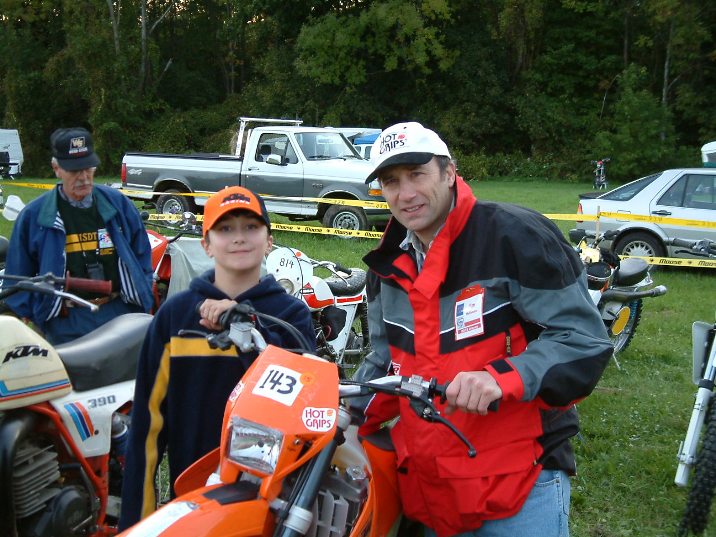

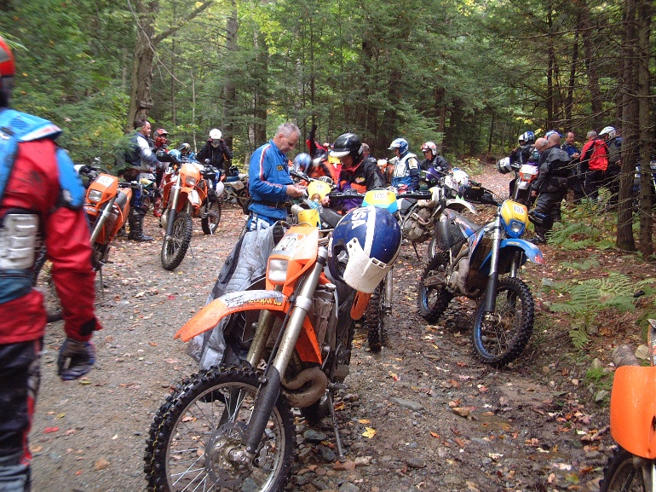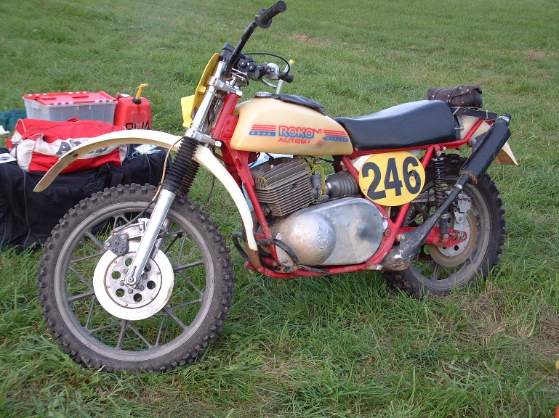

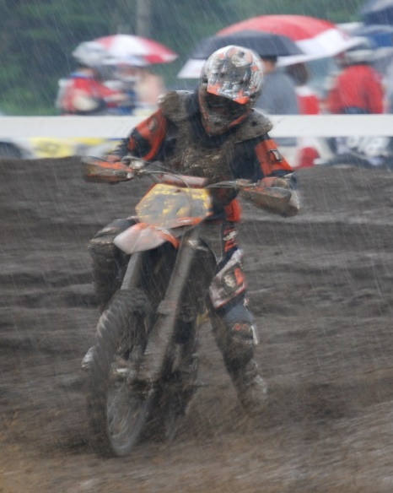

Ben Hollander # 471 at a muddy motocross in Winchester, New Hampshire, riding a KTM 250

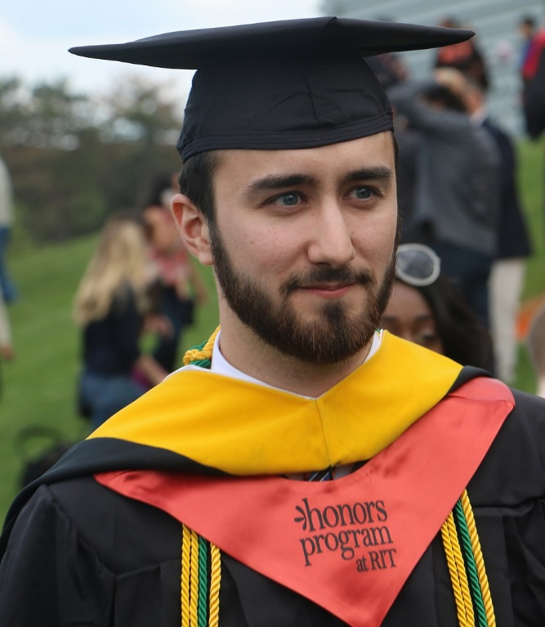
When he competed at age 7 on the Polini 50cc motocrosser, he had a flawless season in a Vermont MX series with a perfect 8 first place trophies. Ben competed for many years until raising his own family. Ben has never been seriously injured, except for one broken arm when someone used him for traction in a turn, and a broken collarbone. Now that he has two sons of his own, he has given up motocross completely. He barely has time for using his 3D printer, parenting takes a lot of time. Ben now has two sons Cole and Liam.

Benjamin went on to a mechanical engineering degree, an honors program student at Rochester Institute of Technology. Although I carefully never encouraged him to become an engineer, and wanted him to pursue his own thing, perhaps hanging out with dad was a factor, Ben seemed to have a knack for mechanical contraptions. He once modified an older Ford Falcon from drum brakes to disc brakes and installed a factory “crate engine”. Now he works on overseeing the designing and production of actuators and controls in military aircraft near Buffalo, NY.

Riding influenced by Czechoslovakia ISDT rider: You don’t finish multiple ISDT endurance competitions without picking up a unique riding style. In one of the five ISDT events, I had the good fortunate to ride on the same rider “minute” as Zdenek Cespiva, a Jawa motorcycle factory rider who was a Czechoslovakia Army World Trophy Team member. The Jawa Trophy Team often dominated the ISDT back in the 1970s.

The Jawa Team rode full time as part of the military in that country. They were all very fast, but never looked the slightest bit frantic. They were all celebrated national heroes and their family housing was taken care of by the government. I learned a lot from Zdenek and his stealthy Jawa motorcycle riding technique. There was an interesting courtesy that develops when you ride for 6 days with the same riders on your “minute”. After a few days of riding each of us was careful not to throw up rocks unnecessarily when accelerating on a gravel road. That was a nice gesture of courtesy that I had never seen before in competition.

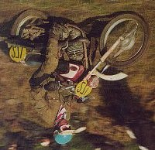

If you knew a faster rider on your minute was close behind you, you would kick out your boot and point quickly to the side you wanted him to pass on. One of my memories of that 1972 Czechoslovakia Six-Days was when I slipped off the trail on the rainy and foggy 6th day into a deep hole. Cespiva actually stopped, casually pulled up his bike on its center-stand, and offered to help me get out. I guess my son picked up a little bit of what I learned from that legendary Six-Days Jawa rider: He became a very cool-headed motocross rider and as a family Peggy, Ben and myself enjoyed motocross for many years. Shown to the right is a Trophy Team rider from Czechoslovakia:

The lesson learned from these professional riders: You don’t have to ride appearing to be on the edge of control to be very fast. ISDT riders have a unique calm measured style compared to a motocross rider. They have to last 6 days, not 45 minutes on the MX track.

1973-2003 ISDT 30th Reunion: I brought a 520cc KTM 4-stroke with Hot Grips® model KW and was glad that it rained, since my hands stayed warm. The KW model I manufactured was something special for dirt bikes, since it had great traction when wet or muddy, molded in a Shell Kraton-G polymer compound.
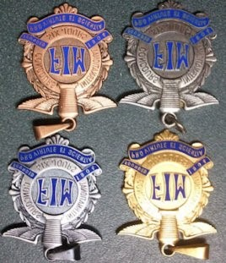

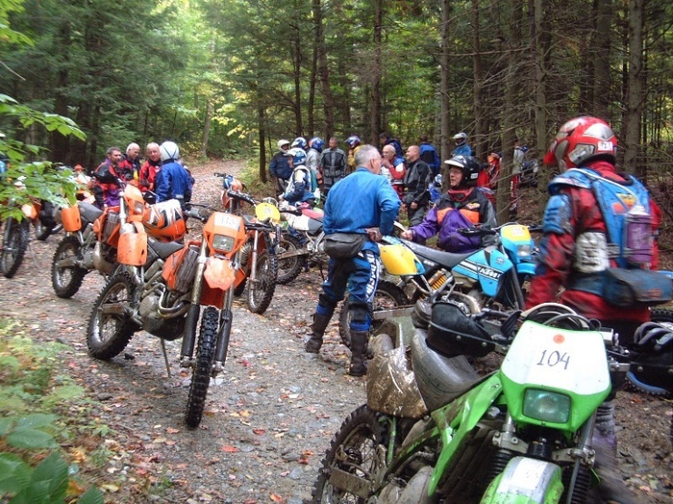

At the reunion John Penton and Malcolm Smith signed the KTM cap that my son had. It seemed so many of the really memorable riders were there, 60+ of us. The Penton clan of Jack, Jeff and Tom, Dane Leimbach, Dave Mungenast, Malcolm Smith, Carl Cranke, Billy Uhl, Dave Latham, Doug Wilford, Don Cutler, Jake Fisher, Ron Bohn, the list just went on and on. We "camped" at the reunion grounds in a trailer, and it was great to see my old riding buddies. The 3-Jim's Rokon team of Jim Simmons, Jim Fogle, and Jim Hollander got together once again. Even Marcia MacDonald came from the Himalayans to the event, I hadn’t seen her since 1976 in Austria when she managed the US Trophy Team. There were many vintage enduro bikes at the reunion, some of them the same that they rode 30 years ago. Many ISDT bikes can be seen at this wonderful online website link: https://www.pinterest.com/jefffox2245/isdt-6-days/

I attended the 40th ISDT reunion at the Jim Hollerich Massachusetts farm site as a spectator, and wished I had signed up as a rider. It was wonderful to see the riders, and especially enjoyable to view the Jim Hollerich motorcycle museum.

In 2023 the 50th ISDT reunion was held in Pownal, Vermont, and 3 Rokons were brought for display including the 1976 Rokon 340 that got the gold medal in Austria and the 1977 RX500 Rokon Prototype shown earlier in this story. Ten of the original 1973 ISDT USA team riders were there, including Jack Penton who is not shown in the photo.

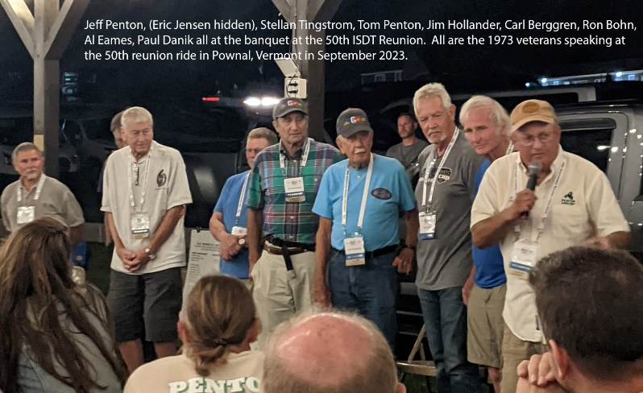

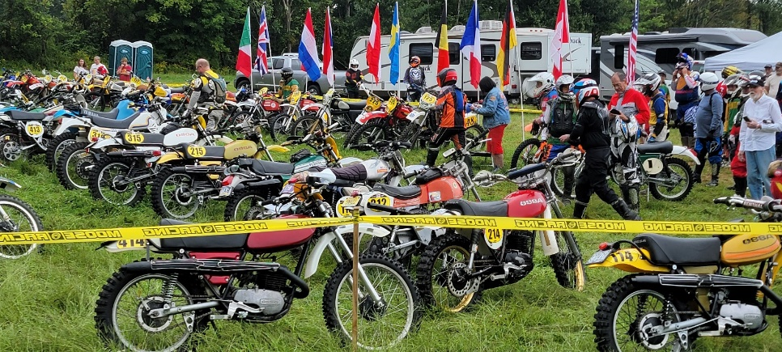

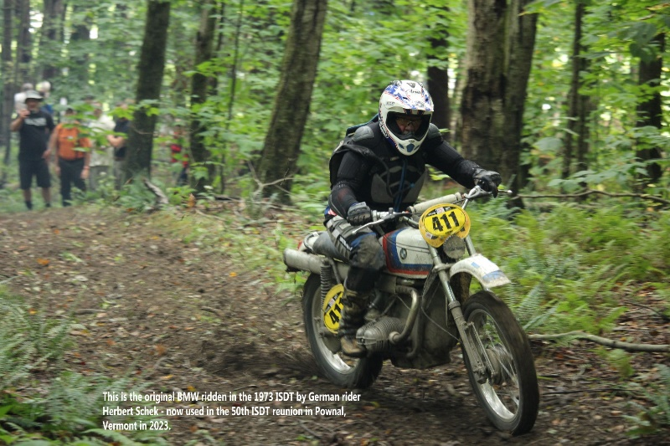

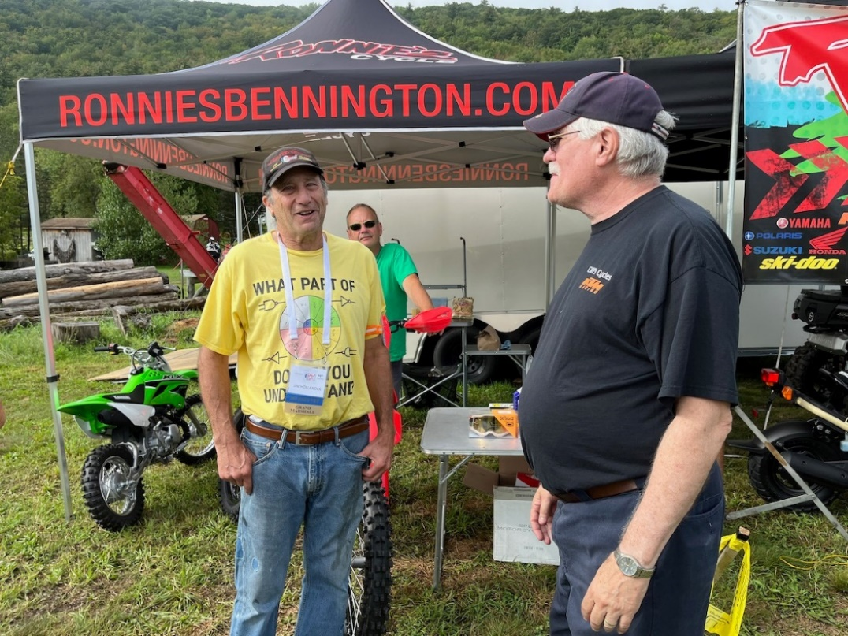

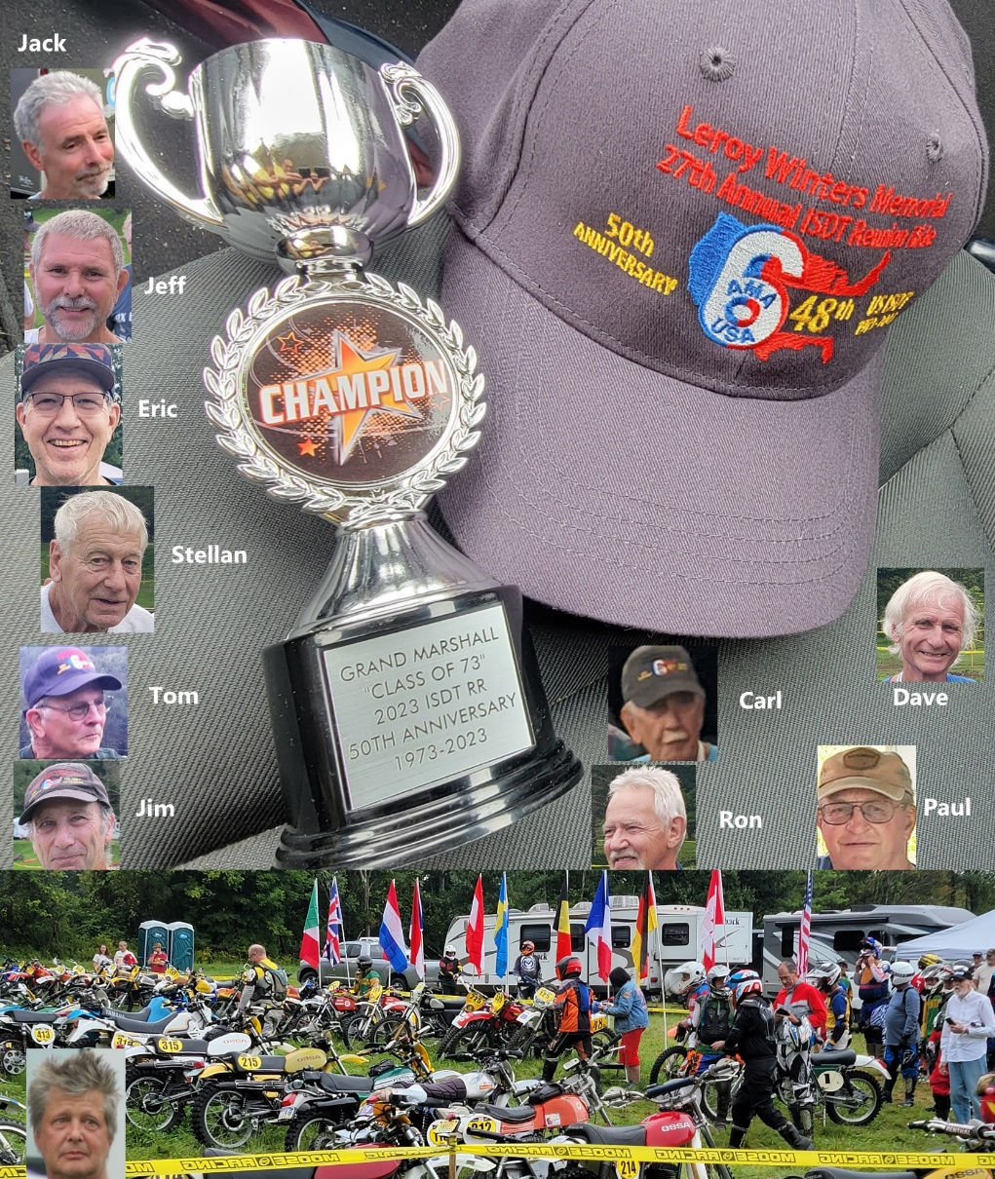

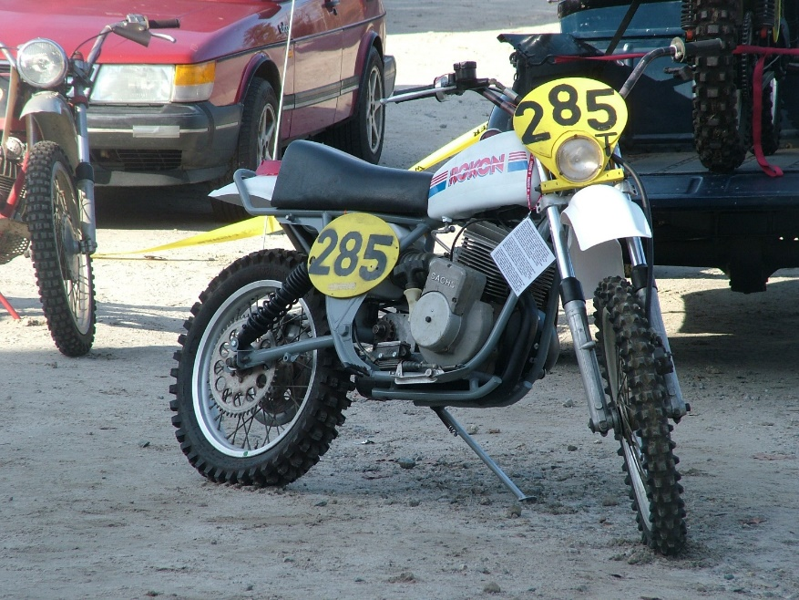

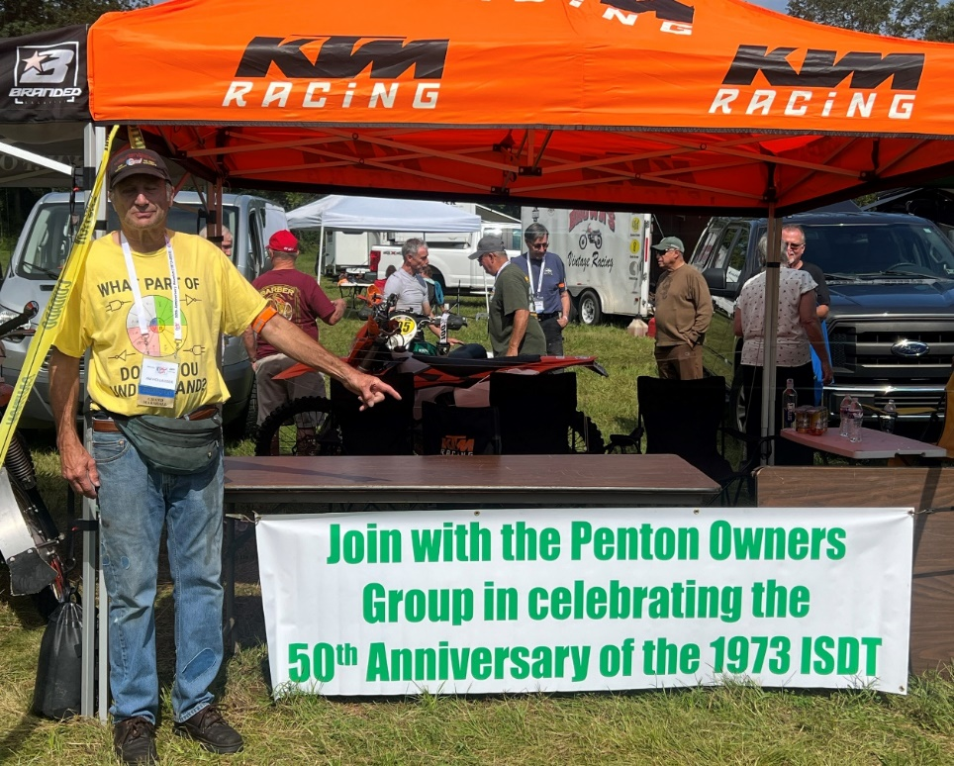

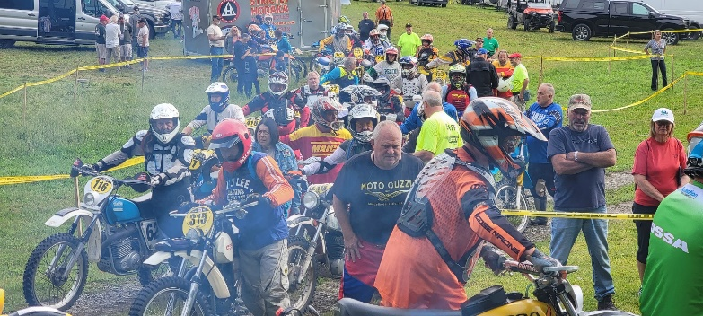

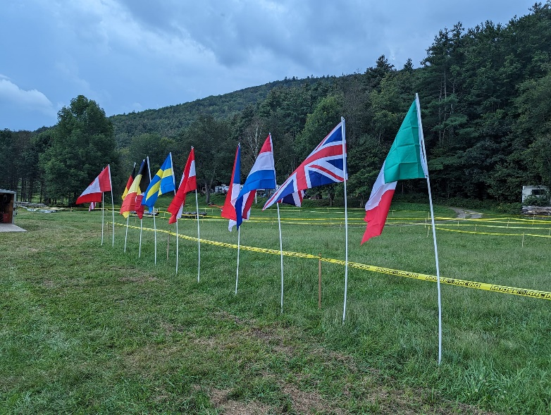
The products below are NOT related to New Hampshire based Hot Grips® Mfg. Inc., and cannot be sold in North America nor even shipped to North America without breaking Intellectual Property Rights laws of both countries. They are from China. There are many other copycats not shown.
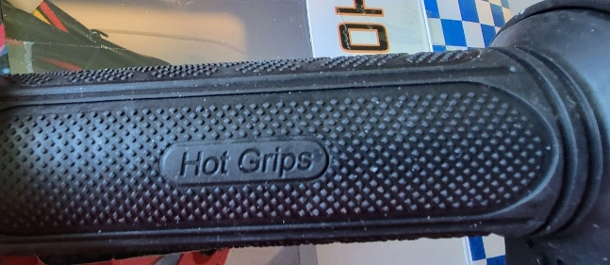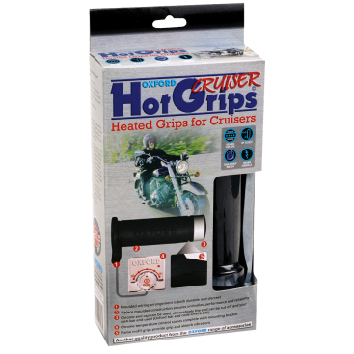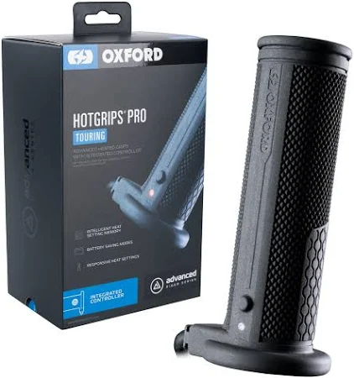

Oxford products are made for a UK firm by Chinese manufacturers:

Copyright USA 2023 James M Hollander Rev. 9-19-2023

